CHAPTER ONE

INTRODUCTION

1.1 Background of the Study
In the modern institutional and corporate ecosystem, the management of physical assets and the governance of material procurement have evolved from administrative peripheral tasks into fundamental drivers of organizational competitiveness and operational resilience. Asset-intensive organizations rely on the seamless coordination of inventory records and requisition approvals to ensure that the right resources reach the right personnel at the right time. Any failure within this chain, whether caused by human error, data inconsistency, or procedural opacity, can cascade into measurable financial losses, compliance violations, and productivity setbacks(K R et al., 2025).
Historically, inventory management and procurement workflows were handled through manual methods: handwritten ledgers, physical requisition forms, and verbal communications between departments. Although these approaches were adequate for small-scale operations, they proved fundamentally inadequate as organizations expanded, diversified their workforce, and adopted multi-branch structures. The limitations of paper-based systems became strikingly apparent during periods of high transaction volume, where the absence of real-time visibility and centralized control led to chronic inefficiencies such as stock discrepancies, unauthorized withdrawals, and delayed approvals that stalled operational continuity(Al-Kahtani, M. S., & Al-Ghamdi, 2021).
The evolution of web technologies has facilitated a paradigm shift from these isolated legacy systems toward centralized, browser-accessible platforms. In this modern framework, the user interface has transitioned from simple form-based data entry into interactive digital storefronts that allow employees to browse available inventory items in a manner analogous to commercial e-commerce platforms. Rather than employees guessing at stock availability or waiting days for confirmation, they can view live inventory counts, filter items by category or department, and submit digital requisitions that are automatically routed for approval, all within a single web application(-, 2024).
Central to these modern systems is the approval workflow, a rule-based process that routes requests through a sequence of predefined approvers using automation logic. Conventional approval processes are characterized by excessive communication overhead, where requisitions bounce between email threads, physical desk trays, and verbal handoffs over the course of several business days. Automated workflow engines address these inefficiencies by enforcing deterministic routing logic, providing real-time status updates, and eliminating the possibility of a requisition being “lost” in someone’s inbox(Holloway, 2024).
Furthermore, the implementation of Role-Based Access Control (RBAC) ensures that these systems operate on the Principle of Least Privilege (PoLP). RBAC maps permissions to organizational roles rather than to individual identities. This approach not only simplifies access administration but also enforces clear boundaries of authority within the system: an employee with a standard user role can submit and track requisitions but cannot approve them or modify inventory records. This separation of duties prevents unauthorized actions, reduces the attack surface for insider threats, and provides auditors with a coherent, verifiable record of every system interaction(Rostami, 2023).
This study is inspired by, and situated within, the operational context of the Cocoa Marketing Company (Ghana) Limited (CMC), the marketing subsidiary of the Ghana Cocoa Board (COCOBOD) responsible for the sale and export of Ghana’s cocoa beans and cocoa products. Like many large public-sector institutions in Ghana, CMC coordinates inventory and internal requisitions across a head office and outstation operations, involving multiple departments and layers of approval authority. Observations of current practice reveal a heavy dependence on paper requisition forms, spreadsheet-based stock records, and manual, signature-driven approval chains. These practices give rise to approval delays, weak audit trails, stock records that do not reflect physical reality, and limited controls over who may view or modify sensitive inventory data.
By designing and implementing a Web-Based Inventory and Requisition Management System grounded in the requirements of an organization such as CMC, this project aims to deliver a practical solution that directly addresses these deficiencies. The system integrates real-time inventory visibility, a multi-role approval workflow, and comprehensive audit logging within a single web application, thereby bridging the gap between enterprise software engineering theory and practical deployment in a resource-constrained organizational environment(Al-Kahtani, M. S., & Al-Ghamdi, 2021).

1.2 Problem Statement
Despite the widespread availability of advanced software solutions, a significant proportion of businesses, estimated at approximately 41% by industry surveys, still rely on manual processes for logging and managing their inventory. This reliance on legacy methods creates a cluster of interrelated operational and security problems that collectively undermine organizational efficiency, financial accountability, and regulatory compliance.
The specific problems addressed by this study include the following:
- Approval Latency and Lack of Status Visibility: In manual systems, purchase orders and requisition forms often bounce between email threads, physical desk trays, and informal verbal handoffs. This decentralized approach means that a single absent approver, whether out of the office or overwhelmed with other duties, can stall an entire procurement cycle for two to five business days. Employees who submit requisitions have no reliable mechanism for tracking their request status in real time, leading to repeated follow-up calls and emails that consume productive work hours and generate frustration across all stakeholders.
- Accountability and Audit Risks: Verbal approvals and paper signatures are notoriously difficult to verify and are frequently challenged during internal and external audits. A common pain point occurs when key personnel temporarily delegate their authority verbally during absence; audit investigators subsequently find it impossible to attribute specific approval decisions to named individuals. This lack of a verifiable audit trail exposes organizations to regulatory penalties, increases the cost of compliance exercises, and creates opportunities for fraud through plausible deniability.
- Data Inconsistency and Phantom Stock: Manual tracking fails to provide real-time data currency. When stock levels are not updated instantaneously upon each transaction, stale records persist in spreadsheets. These phantom stock records lead to situations where employees submit requisitions for items that are physically out of stock, causing downstream confusion, wasted administrative effort, and project delays. Conversely, items may appear consumed in the records when they are actually present in the warehouse, leading to unnecessary procurement and budget overspending.
- Security and Unauthorized Access: Without a formal RBAC framework, sensitive inventory and procurement records are frequently over-exposed to individuals who lack legitimate business need. The prevalent "everyone is an admin" anti-pattern in spreadsheet-based systems allows any user with file access to modify stock quantities, delete transaction records, or view confidential financial data. This creates significant risks of insider fraud and data integrity violations that are difficult or impossible to detect without comprehensive access logging.
- Concurrency and Race Conditions: In multi-user environments where several staff members access the same inventory records simultaneously, naive "read-then-write" database operations introduce the risk of Time-of-Check-to-Time-of-Use (TOCTOU) race conditions. If two users independently read a stock count of one remaining unit and both proceed to reserve that unit, the result is a double-allocation error: both users believe they have secured the item, but only one physical unit is available. This class of software bugs, if unaddressed, leads to operational conflicts and inventory discrepancies that erode trust in the system.
This project directly addresses these critical gaps by designing and implementing a web-based system that integrates a distributed architecture with a robust multi-step approval matrix, ensuring every requisition is tracked, authorized, and fulfilled through a secure, auditable, and conflict-free digital process.

1.3 Aim of the Study
The primary aim of this study is to design and implement a Web-Based Inventory and Requisition Management System for the Cocoa Marketing Company that automates the complete lifecycle of an inventory requisition. In achieving this aim, the system seeks to provide staff of the organization with a unified platform that improves transparency, accelerates decision-making, and enforces governance standards consistently across all branches and departments.

1.4 Objectives of the Study
To achieve the stated aim, the following specific objectives will be pursued:
- To analyse the existing manual inventory and requisition processes of the Cocoa Marketing Company and identify their operational, security, and accountability weaknesses.
- To design a centralized, web-based inventory system that gives authorized staff real-time visibility of stock levels across the head office and branch warehouses.
- To develop a role-based requisition module in which submitted requests are automatically routed through the appropriate approval hierarchy, covering the Head of Department, IT Manager, Account, and Account Manager levels as applicable.
- To implement security and accountability controls, including role-based access control, separation of duties, and an append-only audit trail of all approvals and stock movements.
- To safeguard data integrity under concurrent multi-user access through atomic database transactions that prevent the double allocation of stock.
- To test and evaluate the developed system against the functional and non-functional requirements identified during the system analysis phase.

1.5 Research Questions
This study seeks to answer the following research questions:
- How can real-time inventory visibility reduce phantom stock requests and reconciliation errors within the organization’s procurement processes?
- To what extent can automated workflow routing reduce approval cycle times for departmental requisitions compared to paper-based and email-based approval flows?
- How effective are role-based access control and separation of duties constraints in preventing unauthorized requisition approvals within a multi-branch, multi-role organization?
- How can atomic database update strategies mitigate the risks of race conditions in a multi-user inventory management system?
- In what ways does centralized audit logging improve the organization’s readiness for internal and external compliance audits compared to manual record-keeping?

1.6 Significance of the Study
This study provides significant value to multiple stakeholders within an organization as well as to the broader academic and professional community engaged in enterprise software development and information systems research. The significance is articulated at several levels:

Organization
The system enhances organizational productivity and operational efficiency by removing the communication overhead and administrative friction that characterize manual approval processes. By reducing approval cycle times from an average of two to five business days to a target of under twenty-four hours, the organization gains a measurable competitive advantage in the speed and reliability of its internal resource distribution. The elimination of phantom stock records and double-allocation errors directly reduces procurement costs and minimizes the financial losses associated with inventory shrinkage.

Management
Senior management and department heads gain access to real-time dashboards that provide granular visibility into consumption patterns, pending approvals, departmental spending trends, and stock depletion trajectories. This data-driven intelligence enables more informed budgetary decisions, proactive resource planning, and timely intervention when unusual procurement patterns, possibly indicative of fraud or misuse, are detected. The centralized approval matrix also ensures that management maintains clear, documented authority over procurement decisions at every level of the organizational hierarchy.

Auditors and Compliance Officers
The system ensures audit readiness by maintaining a retrievable, tamper-evident record of every transaction, approval decision, and delegation event. The append-only audit log table structure means that historical records cannot be modified or deleted without a clearly traceable administrative action. This dramatically reduces the cost and duration of internal and external compliance exercises, as auditors can retrieve complete transaction histories through a structured query interface rather than manually reconstructing approval chains from email archives and paper files. The system also directly supports compliance with regulatory frameworks that mandate segregation of duties and documented approval evidence.

Stores Personnel
The Stores role within the system gains clear operational benefits: they receive digitally authorized fulfillment requests that have already passed through the complete approval chain, eliminating the problem of unauthorized "grab-and-go" removals that lead to inventory discrepancies. The system provides stores personnel with a prioritized queue of pending fulfillment actions, complete with item specifications and approver identities, enabling them to execute fulfillments accurately and efficiently without needing to verify authorizations through external communication channels.

Employees
End users benefit from a simplified, intuitive requisition process accessed through a modern web interface that is accessible from any device with a browser. The digital storefront model allows employees to make informed requests based on actual stock availability, while the status tracking functionality eliminates the anxiety and wasted time associated with following up on pending requisitions. Notifications and email alerts ensure that employees are informed promptly of approval decisions, enabling them to plan their work activities accordingly.

Significance to Academia
From an academic perspective, this study contributes a documented case study in the application of workflow formalism, ACID transaction theory, and NIST RBAC standards to a real-world organizational problem. The integration of Petri Net-based workflow correctness verification, Optimistic Concurrency Control, and a multi-path Business Rules Engine within a single cohesive web application provides a rich empirical basis for future research in enterprise information systems design and deployment.

1.7 Scope of the Study
This study covers the design, development, and testing of a Web-Based Inventory and Requisition Management System modelled on the operational requirements of the Cocoa Marketing Company (CMC), a subsidiary of the Ghana Cocoa Board. The boundaries of the study are defined as follows.
Functionally, the system covers user authentication and role-based access for eight organizational roles (Admin, User, Account, HOD, Deputy HOD, IT Manager, Account Manager, and Stores); management of departments and users; inventory item management with real-time stock visibility; submission, approval, and fulfilment of internal requisitions through automated multi-step workflows; low-stock alerting; and an audit trail of all significant system actions(Al-Kahtani, M. S., & Al-Ghamdi, 2021).
Operationally, the system handles internal requisitions only, that is, the distribution of stock already held in the organization’s stores or warehouses to requesting departments. It supports both head-office and branch-office requisitions, with distinct approval paths for each. The system does not cover CMC’s core cocoa sales and export operations, external procurement activities such as vendor selection, supplier management, or purchase order generation, nor payment processing or integration with third-party ERP, accounting, or human resource systems.
In terms of users, the system is intended exclusively for authenticated internal staff; it provides no public-facing or customer-facing interfaces. Technically, the study is limited to a web application accessible through modern browsers on the organization’s network; native mobile applications and offline operation are outside its scope.

1.8 Limitations of the Study
While the system is designed to be comprehensive and robust, the following limitations are acknowledged and should be considered when interpreting the findings and generalizing the results:
- Connectivity Dependency: As a web-based system, its availability is strictly contingent on the stability and reliability of the organization's intranet or internet infrastructure. In environments with frequent network interruptions, users may experience service unavailability that impedes their ability to submit or approve requisitions in a timely manner. Offline functionality is beyond the scope of this study.
- Hardware and Scaling Constraints: While the system is designed with microservices-inspired modular principles, the initial implementation is optimized for deployment on standard server environments. Organizations experiencing extremely high transaction volumes may require additional infrastructure investment in load balancing, database replication, and horizontal scaling to maintain performance under peak load conditions.
- Data Migration Complexity: Th initial inventory and user data provided during system setup are accurate and properly structured. It does not address the complexities of cleaning and migrating "dirty data" from legacy spreadsheets or existing manual records, which may contain inconsistencies, duplicate entries, and formatting anomalies that require significant preprocessing before they are suitable for import into the system.
- Integration Limitations: The system is designed as a standalone application and does not include native integration connectors for third-party enterprise resource planning (ERP) systems, financial accounting platforms, or human resources information systems. Such integrations, while architecturally possible through the system's RESTful API, are outside the scope of this study.
- Single Organization Context: The system is designed and tested within the context of a single organizational configuration. Its generalizability to organizations with fundamentally different approval hierarchies, significantly larger numbers of roles, or more complex branching structures may require customization and additional development effort.

1.9 Organization of the Study
The remainder of this project report is structured into four subsequent chapters. Chapter Two (Literature Review) provides a review of conceptual, theoretical, and empirical research relevant to inventory management, workflow automation, database transaction integrity, and role-based access control, and concludes with a gap analysis. Chapter Three (Methodology) presents the system analysis, the Agile development methodology adopted, the system architecture and design, the use case model, the entity relationship model, the database schema, and the requisition approval workflows. Chapter Four (System Implementation and Testing) describes the tools and technologies used, documents the implementation of the key system components, and reports the results of the testing exercises. Chapter Five (Summary, Conclusion, and Recommendations) synthesizes the findings of the project, evaluates the extent to which the objectives were achieved, and provides recommendations for future enhancement.

CHAPTER TWO

LITERATURE REVIEW

2.1 Introduction
The development of a Web-Based Inventory and Requisition Management System demands a multidisciplinary academic foundation that synthesizes principles drawn from supply chain management, database transaction theory, software engineering methodology, and organizational security governance. This chapter provides a structured and comprehensive review of the existing literature across these domains, establishing the theoretical and empirical context within which the proposed system is situated.
The review is organized into four primary sections. The conceptual review examines the fundamental constructs of inventory management, approval workflow design, and role-based access control as understood in current academic and practitioner literature. The theoretical review delves into the mathematical and formal models that underpin workflow correctness, including Petri Nets and WF-nets, and the database transaction properties that guarantee data integrity in high-concurrency environments. The empirical review surveys existing systems and real-world implementations that share design features with the proposed system, providing benchmarks against which its design decisions can be evaluated. The chapter concludes with a gap analysis that identifies the specific limitations of existing approaches and articulates the contributions of this study(Abdila et al., 2024).

2.2 Conceptual Review

2.2.1 The Concept of Inventory Management
Inventory management is formally defined as the systematic process of sourcing, storing, and tracking raw materials, work-in-progress goods, and finished products across the supply chain. It functions as the central hub connecting procurement, production, and distribution activities, and its effectiveness has a direct and measurable impact on organizational profitability, customer satisfaction, and operational continuity. The fundamental challenge of inventory management lies in balancing the competing costs of overstocking, which ties up capital and generates carrying costs, and understocking, which causes operational delays and lost productivity (Wild, 2017; Chopra & Meindl, 2019).
The historical development of inventory management theory has progressed through several significant phases. Early approaches relied entirely on manual counting and periodic reconciliation, which were adequate for simple, low-volume operations but inadequate for complex organizational environments. The introduction of perpetual inventory systems, which aim to update stock records with every transaction, represented a significant improvement in real-time accuracy. The emergence of Enterprise Resource Planning (ERP) systems in the 1990s brought integrated, organization-wide inventory visibility for the first time, although at substantial cost and implementation complexity. More recently, cloud-based and web-native inventory solutions have democratized access to sophisticated inventory management capabilities for organizations that cannot afford or sustain full ERP implementations (Richards, 2017; Laudon & Laudon, 2020).
Research consistently demonstrates that approximately 41% of businesses still rely on manual processes for inventory logging, despite the availability of software solutions. This persistence of manual methods is attributable to several factors: the perceived complexity and cost of digital transformation, resistance to change within organizations, inadequate technical infrastructure, and a lack of awareness of available solutions suited to smaller operational scales. The consequences of this continued reliance on manual methods include stock discrepancies averaging 8% of inventory value, approval cycle times of two to five business days, and audit deficiency findings that impose significant remediation costs.

2.2.2 Approval Workflows and Business Process Management (BPM)
An approval workflow is a rule-based, automated process that routes requests through a predetermined sequence of reviewers and decision-makers based on configurable business logic. Within the broader discipline of Business Process Management (BPM), approval workflows represent a critical mechanism for enforcing governance, accountability, and procedural compliance in organizational operations. The theoretical foundations of BPM draw on process algebra, automata theory, and organizational management science to provide a rigorous basis for designing, analyzing, and improving business processes (Dumas, La Rosa, Mendling, & Reijers, 2018).
Workflow automation research distinguishes between several primary categories of workflow structure. Sequential workflows route requests in a fixed, step-by-step order where each approver must complete their review before the next can act; these are most appropriate for high-risk processes that require a strict chain of authority. Parallel workflows allow multiple approvers to review the same request simultaneously, significantly reducing turnaround time for processes where independent stakeholders evaluate different aspects of the same request. Conditional workflows employ IF/THEN logic to dynamically route requests based on contextual criteria such as monetary value, department of origin, or item category. Hierarchical workflows follow the organizational chain of command, ensuring that approval authority flows in alignment with formal organizational structure(Stavenko et al., 2013).
The shift from manual to automated workflow management has been extensively studied and consistently demonstrates significant performance improvements. Research indicates that automated workflows reduce average cycle times by up to 80% compared to manual email-based processes, while simultaneously improving compliance rates by ensuring that no step can be bypassed and every decision is electronically recorded. The elimination of physical routing removes geographical barriers and enables approvals to be processed from any location with internet access, which is particularly significant for organizations with distributed branch structures.

2.2.3 Role-Based Access Control (RBAC)
Role-Based Access Control is a security paradigm that regulates user access to system resources by assigning permissions to roles, which are then assigned to users based on their organizational function. First formally proposed by Ferraiolo and Kuhn in 1992 and subsequently standardized by the National Institute of Standards and Technology (NIST) in 2004, RBAC has become the predominant access control model for enterprise information systems due to its scalability, administrative simplicity, and strong alignment with real-world organizational structures (Stallings & Brown, 2018).
The fundamental principle underlying RBAC is the Principle of Least Privilege (PoLP), which mandates that every user, process, or system component should be granted only the minimum permissions necessary to perform its defined function. This principle limits the scope of potential damage from insider threats, software vulnerabilities, or user errors by ensuring that no single actor has the authority to perform actions beyond their legitimate business role. In a properly implemented RBAC system, even a compromised user account can only perform the actions associated with that user's assigned roles, significantly limiting the blast radius of a security incident(Rostami, 2023).
RBAC systems operate through four core components: Users, who are the entities requiring access; Roles, which are collections of permissions associated with specific job functions; Permissions, which are grants to perform defined operations on protected resources; and Sessions, which represent the temporal mapping between an active user and the roles they have activated. Advanced RBAC models add role hierarchies, where senior roles inherit the permissions of subordinate roles, and Separation of Duties (SoD) constraints, which prevent a single user from combining roles that could be exploited to circumvent controls.

2.3 Theoretical Review

2.3.1 Workflow Formalism: Petri Nets and WF-nets
To rigorously analyze workflows for structural correctness, researchers and system architects employ Petri Nets, a mathematical modeling language introduced by Carl Adam Petri in 1962. A Petri Net is a directed bipartite graph consisting of two types of nodes: Places (P), which represent conditions or states, and Transitions (T), which represent events or actions. Arcs connect places to transitions and transitions to places, and tokens, represented as markers within places, indicate the current state of the system. A transition fires when all its input places contain sufficient tokens, consuming the input tokens and producing tokens in the output places.
For modeling business workflows, a specialized extension called a Workflow Net (WF-net) is employed. A WF-net imposes two structural constraints on the basic Petri Net: the existence of a single, unique start place with no incoming arcs, representing the initiation of the workflow, and a single, unique end place with no outgoing arcs, representing its successful completion. Additionally, the entire net must remain strongly connected when a virtual transition connecting the end place back to the start place is added. These constraints ensure a well-defined entry and exit point for every workflow instance(van Zelst & Leemans, 2020).
The primary correctness criterion for WF-nets is the Soundness Property, which formally guarantees three conditions: every workflow instance that starts can always reach the termination state from any reachable marking; the termination state is always reached with exactly one token in the end place and no tokens elsewhere; and there are no dead transitions, meaning every transition in the workflow can potentially fire in some execution scenario. Soundness verification can be performed algorithmically using state-space analysis techniques, enabling system designers to detect deadlocks, livelocks, and orphaned states before deployment (van der Aalst, 2016).

2.3.2 Database Transaction Theory and ACID Properties
Maintaining data integrity in high-throughput, multi-user inventory systems requires adherence to the ACID transaction properties, a theoretical framework that defines the guarantees a database management system must provide to ensure reliable transaction processing (Silberschatz, Korth, & Sudarshan, 2020). The four ACID properties are as follows.
Atomicity guarantees that every operation within a transaction is treated as an indivisible unit: either all operations complete successfully, or none of them take effect. In the context of inventory management, this means that the act of decrementing a stock count and simultaneously creating an audit log entry must either both succeed or both fail. Partial execution of such a transaction would result in data inconsistency where stock levels do not correspond to logged transactions(van Zelst & Leemans, 2020).
Consistency ensures that every committed transaction brings the database from one valid state to another valid state, preserving all defined constraints, integrity rules, and business rules. For example, a transaction that would reduce a stock quantity below zero must be rejected, as it would violate a non-negativity constraint, ensuring that the database always reflects a logically coherent representation of reality.
Isolation guarantees that the concurrent execution of multiple transactions produces results equivalent to some serial execution of those transactions, preventing one incomplete transaction from seeing intermediate state changes made by another. Different isolation levels, from Read Uncommitted to Serializable, offer varying trade-offs between performance and protection against concurrency anomalies such as dirty reads, non-repeatable reads, and phantom reads.
Durability guarantees that once a transaction is successfully committed, its effects persist permanently, even in the event of system crashes, power failures, or hardware malfunctions. This is typically achieved through write-ahead logging mechanisms that ensure transaction records are written to persistent storage before the commit acknowledgement is returned to the client(van Zelst & Leemans, 2020).

2.4 Transactional Concurrency Control
In multi-user inventory systems, concurrency control is essential to prevent data integrity violations when multiple users simultaneously attempt to reserve or update the same inventory records. Three primary strategies are employed in practice, each with distinct performance and safety characteristics(van Zelst & Leemans, 2020).

2.4.1 Pessimistic Locking
Pessimistic locking employs SQL directives such as SELECT ... FOR UPDATE to acquire exclusive locks on targeted rows at the moment they are read. Any other transaction attempting to read or modify locked rows must wait until the lock is released upon the first transaction's completion. This approach provides strong consistency guarantees but introduces the risk of lock contention and deadlocks in high-concurrency environments, where multiple transactions wait for locks held by each other, creating a circular dependency that must be resolved through timeout-based rollback(Kiringa & Gabaldon, 2010).

2.4.2 Optimistic Concurrency Control (OCC)
Optimistic Concurrency Control (OCC) permits transactions to proceed without acquiring locks, operating on the assumption that conflicts will be rare. Each inventory record includes a version number field that is incremented with every update. When a transaction reads a record, it captures the current version number. At commit time, the transaction's UPDATE statement includes a WHERE clause that checks that the version number in the database still matches the captured value. If another transaction has modified the record in the interim, the version numbers will not match, the update will affect zero rows, and the application detects the conflict and retries the transaction. OCC is highly effective in read-heavy workloads where write conflicts are infrequent, offering superior throughput compared to pessimistic locking (Kleppmann, 2017), (Anil Kumar Bayya, 2024).

2.4.3 Atomic Updates
Atomic update strategies consolidate the availability check and the stock decrement into a single SQL statement, eliminating the time gap between check and update that creates TOCTOU vulnerabilities. The canonical form is: UPDATE inventory SET available_qty = available_qty - 1 WHERE item_id = ? AND available_qty > 0. The database engine evaluates the condition and performs the update as an atomic operation; the application then checks the number of rows affected to determine whether the update succeeded. This approach combines the simplicity of pessimistic locking with improved performance characteristics, making it the preferred strategy for high-frequency reservation operations in inventory systems(Tanaka et al., 2019).

2.5 Mathematical Formalization of NIST RBAC
The NIST RBAC standard provides a set-theoretic formalization of role-based access control that is essential for rigorously specifying and verifying the security architecture of access-controlled systems. The model is defined in terms of the following foundational sets and relations: U, R, P, and S, representing the sets of all Users, Roles, Permissions, and active Sessions in the system respectively. The User Assignment relation UA is a subset of the Cartesian product of U and R, mapping users to roles in a many-to-many relationship. The Permission Assignment relation PA maps permissions to roles. The Role Hierarchy RH defines a partial order on roles, where a role at a higher level inherits all permissions of subordinate roles(Jin et al., 2012).
To manage organizational risk, the NIST model incorporates Separation of Duties (SoD) constraints in two forms. Static SoD (SSD) operates at the administrative level, preventing conflicting roles from being assigned to the same user simultaneously. Dynamic SoD (DSD) operates at the session level, allowing a user to hold potentially conflicting roles in their profile but preventing them from activating both within the same authenticated session. These constraints are essential for ensuring that no individual user can combine permissions in ways that would enable them to initiate, approve, and fulfill a requisition without independent oversight, a critical control in preventing procurement fraud(Sandhu et al., 2000).

2.6 Empirical Review

2.6.1 Institutional Routing: The Cayuse System
A prominent real-world example of institutional workflow routing is the Cayuse system implemented at Stephen F. Austin State University. This system manages complex research grant proposals through a multi-stage routing workflow that involves principal investigators, department chairs, research compliance officers, and financial administrators. The Cayuse implementation demonstrates the practical effectiveness of hierarchical workflow routing in reducing the administrative burden associated with complex, multi-party approval processes in institutional settings. Its architecture, which separates the routing logic from the form data, provides a model for the flexible BRE design employed in the proposed system(Spatt, 2020).

2.6.2 Commercial ERPs: Odoo and BarCloud
Among commercial ERP platforms, Odoo and BarCloud represent contrasting approaches to inventory and requisition management. Odoo is a comprehensive, modular ERP that incorporates demand forecasting algorithms, automatic reorder point calculation, and multi-warehouse management. Its breadth of functionality, however, comes at a significant implementation complexity cost, making it unsuitable for organizations that require only a focused requisition management capability. BarCloud, by contrast, implements a digital storefront model for internal inventory that allows staff to browse items and submit requisitions through a controlled workflow, demonstrating the practical value of the e-commerce browsing paradigm for internal procurement. Both systems, however, lack the specific multi-path conditional approval routing and Branch/Head-Office differentiation that characterize the proposed system(Ruivo et al., 2015).

2.7 Gap Analysis

2.7.1 The Manual Process Inefficiency Gap
The literature consistently documents that 41% of businesses continue to rely on manual inventory management processes, resulting in approval cycle times of two to five days, phantom stock rates of approximately 8%, and recurring audit findings. The proposed system directly addresses this gap through workflow automation and real-time digital inventory management(Noor Romy Rahwani et al., 2023).

2.7.2 The Concurrency and Race Condition Gap
Many existing web-based inventory systems employ naive read-then-write operations that are vulnerable to TOCTOU race conditions in multi-user environments. Few systems document explicit concurrency control strategies at the application level. The proposed system addresses this gap through the implementation of Optimistic Concurrency Control with version stamping and atomic SQL update patterns.

2.7.3 The Complexity vs. Usability Gap
Enterprise ERPs offer powerful functionality but impose prohibitive implementation complexity and licensing costs for mid-sized organizations. Simple spreadsheet tools lack the necessary access controls and workflow automation. The proposed system bridges this gap by providing a focused, role-specific feature set that covers the complete requisition lifecycle without the overhead of a full ERP implementation, deployed on an open-source technology stack that eliminates licensing costs.

2.7.4 The Multi-Branch Conditional Routing Gap
Most reviewed systems either support a single, organization-wide approval workflow or require complex and expensive customization to implement branch-specific routing logic. The proposed system incorporates multi-branch conditional routing as a first-class architectural feature, with the BRE automatically selecting the appropriate approval path based on the requisition's origin branch and department.

2.8 Summary of Literature Review
The literature confirms that the transition from manual to automated, role-specific inventory and requisition management workflows is not merely a technological convenience but an operational necessity for organizations seeking to maintain competitive efficiency, financial accountability, and regulatory compliance. Theoretical frameworks, including Petri Nets for workflow correctness verification, ACID transaction theory for data integrity assurance, and NIST RBAC formalization for access control specification, provide a rigorous foundation for the proposed system's design. Empirical evidence from implemented systems such as Cayuse, Odoo, and BarCloud validates the practical effectiveness of the design patterns employed while also highlighting specific capability gaps that the proposed system is uniquely positioned to address. The following chapter presents the methodology through which these theoretical and empirical insights are translated into a concrete system design and implementation.

CHAPTER THREE

METHODOLOGY

3.1 Introduction
The development of a robust, secure, and scalable Web-Based Inventory and Requisition Management System requires a systematic and well-justified approach to software engineering that balances the competing demands of rapid feature delivery, rigorous quality assurance, and architectural soundness. This chapter presents the methodological framework employed in this project, encompassing the analysis of the existing and proposed systems, the software development methodology adopted, the system architecture and design, the use case model for each of the eight organizational roles, the entity relationship model and database schema, and the formal specification of the three requisition approval workflows.
The methodological choices made in this chapter are grounded in the theoretical and empirical findings presented in the preceding literature review. The selection of Agile as the development methodology reflects the iterative, feedback-driven nature of complex system development, the choice of a relational database reflects the requirement for ACID transaction support identified in the theoretical review, and the design of the approval workflow engine reflects the workflow formalism analyzed in the conceptual framework(Al-Saqqa et al., 2020).

3.2 System Analysis

3.2.1 Analysis of the Existing System
The analysis of the existing system was conducted through a combination of structured observations, informal interviews with organizational stakeholders, and a review of current operational documents, including sample requisition forms, spreadsheet templates, and email approval chains. This investigation revealed a consistent pattern of manual, paper-based processes characterized by the following critical deficiencies.
Approval Latency: Requisitions are managed through informal email chains or physical form routing, where a single absent approver, whether on leave, traveling, or overwhelmed with other duties, can suspend the entire procurement cycle for two to five business days. The absence of automated escalation or delegation mechanisms means that pending requests often sit without action until the approver returns.
Phantom Stock Records: Inventory stock counts in spreadsheets are typically updated on a periodic basis, often weekly or monthly, rather than in real-time. This introduces a chronic data lag during which employees submit requisitions for items that are already out of stock or have been reserved for other purposes. The resulting "phantom stock" requests waste both the employee's time and the administrator's resources in processing requests that cannot be fulfilled.
Lack of Accountability and Auditability: Manual signatures on paper forms provide weak evidence of approval, as they are susceptible to forgery, ambiguity, and loss. Verbal delegations of approval authority during periods of absence create accountability gaps that cannot be reconstructed during audits. The inability to produce a coherent, time-stamped approval trail for any given requisition is a persistent audit deficiency that exposes the organization to regulatory risk.
Security Vulnerabilities: Spreadsheet-based inventory records lack access control mechanisms, meaning that any personnel with access to the shared drive or network folder can view, modify, or delete inventory data without restriction. This over-exposure of sensitive financial and operational data creates significant risks of both accidental and malicious data manipulation.
Concurrency Conflicts: In offices where multiple staff members share access to the same inventory spreadsheet, simultaneous editing creates version conflicts, with changes made by one user overwriting or obscuring changes made by another. These conflicts may not be detected for hours or days, resulting in inventory records that are inconsistent with physical stock levels.

3.2.2 Analysis of the Proposed System
The proposed system is designed to systematically address each deficiency identified in the analysis of the existing system. Its key operational characteristics are as follows.
Real-Time Inventory Visibility: The React-based digital storefront presents employees with a live view of inventory availability, with stock counts updated atomically with every approved transaction. Users can filter the catalog by department, item category, and branch, and the system clearly marks items that are below reorder threshold or out of stock.
Automated Multi-Path Workflow Routing: The Business Rules Engine evaluates each requisition against a set of configurable routing criteria, including the originating department, branch classification, and item category, to automatically assign the requisition to the correct approval path. Approvers receive immediate system notifications when a requisition is assigned to them, eliminating the delay associated with manual routing.
Centralized RBAC Enforcement: Access to every system function is governed by the eight-role RBAC engine, which prevents users from performing actions outside their authorized scope. The system enforces Separation of Duties constraints that prevent any single user from both submitting and approving the same requisition.
Immutable Audit Logging: Every significant system event, including login actions, inventory modifications, requisition submissions, approval and rejection decisions, delegation grants, and fulfillment confirmations, is automatically recorded in an append-only audit log table. This log cannot be modified through the normal application interface, providing auditors with a reliable, time-stamped record of all system activity.
Transactional Integrity: The system employs Optimistic Concurrency Control with version stamping to manage simultaneous access to inventory records, preventing double-allocation errors. All multi-step database operations are wrapped in ACID transactions to guarantee consistency and prevent partial updates(Kumar Anugula Sethupathy, 2019).

3.3 Methodology Used: Agile Software Development
The project adopts the Agile software development lifecycle, chosen for its proven effectiveness in managing evolving requirements through short, iterative development cycles that deliver incremental value while maintaining the flexibility to incorporate feedback and changing priorities. Unlike the traditional Waterfall model, which requires comprehensive upfront specification before development begins, Agile acknowledges that complex software systems are best developed through repeated cycles of planning, implementation, testing, and review (Sommerville, 2016; Pressman & Maxim, 2020).
The Agile approach is particularly well-suited to this project because the complexity of the multi-role approval matrix and the need to integrate multiple technical components, including the RBAC engine, the BRE, and the concurrency control mechanisms, creates a high degree of interdependency that benefits from iterative integration and early testing. By building and testing each subsystem incrementally, integration defects can be detected and resolved early in the development process rather than accumulating as a large backlog of issues to be resolved before deployment.
The iterative cycle through which each Sprint progresses, from planning through design, development, and testing to stakeholder review and the release of a working increment, is illustrated in Figure 3.1.
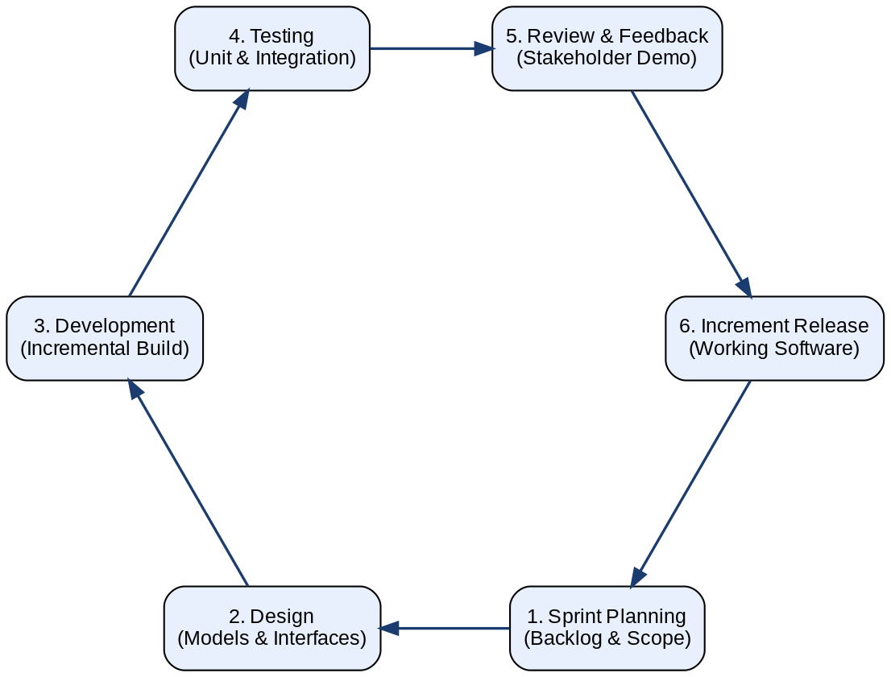
Figure 3.1: Agile Iterative Development Cycle Adopted for the Project

3.3.1 Sprint Planning and Iteration
Development is organized into four primary Sprints, each with a clearly defined scope and deliverables that build upon the work of the preceding Sprint.
Sprint 1 (Foundational Infrastructure): This Sprint focuses on establishing the core technical foundations of the system. Deliverables include the complete database schema design and migration scripts, the implementation of JWT-based authentication with bcrypt password hashing, the foundational RBAC middleware that enforces role-based route protection, and the administrative functions for user and department management. By the end of Sprint 1, a functional authentication system with Admin and User role capabilities is operational.
Sprint 2 (Digital Storefront and Inventory Management): This Sprint delivers the React-based inventory browsing interface, including real-time stock display, category filtering, and item detail views. Backend deliverables include the complete inventory CRUD API with atomic stock update operations. By the end of Sprint 2, users can browse the live inventory catalog and administrators can manage inventory records.
Sprint 3 (Workflow Logic and Approval Matrix): This Sprint implements the Business Rules Engine and the three specialized approval workflow paths. It includes the notification system for alerting approvers of pending actions, the requisition status tracking interface for submitting users, and the approval and rejection interfaces for each approver role. By the end of Sprint 3, the complete requisition lifecycle from submission to fulfillment is functional.
Sprint 4 (Refinement, Testing, and Hardening): This Sprint focuses on non-functional quality, including the implementation of low-stock alerting, the finalization of the audit logging system, accessibility improvements to the frontend interface, comprehensive unit and integration testing, and performance optimization of database queries. By the end of Sprint 4, the system is production-ready.
Figure 3.2 summarizes the four development Sprints, the incremental deliverables of each, and the progression toward the production-ready system.
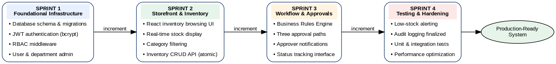
Figure 3.2: Sprint Plan Showing the Four Development Iterations and Their Deliverables

3.4 System Architecture
The system adopts a distributed, microservices-inspired architecture built on the MERN-like technology stack, comprising React for the presentation layer, Node.js with Express for the application logic layer, and MySQL 8.0 for the data persistence layer. This architecture separates concerns across distinct logical services, each responsible for a well-defined domain of functionality, enabling independent development, testing, and deployment of individual components.

3.4.1 API Gateway and Edge Layer
An API Gateway serves as the single entry point for all client requests from the React frontend. The gateway is responsible for authentication validation, where it verifies the JWT bearer token present in each request and rejects unauthenticated requests before they reach the service layer. It also performs rate limiting to protect the inventory service from transaction spikes that could cause performance degradation, and routes validated requests to the appropriate backend controller based on the URL path and HTTP method.
The gateway layer additionally handles Cross-Origin Resource Sharing (CORS) configuration, ensuring that the React frontend, which is served from a separate origin in production environments, can communicate with the API server. It also enforces HTTPS to protect all data in transit from interception, and logs all incoming requests for operational monitoring and security analysis purposes.

3.4.2 Service Layer Logic
The backend service layer is modularized into several distinct logical services, each responsible for a specific domain of the system's functionality.
The Authentication Service handles user registration, login, JWT issuance, and token validation. It integrates with the RBAC engine to attach the authenticated user's role assignments to the request context, enabling downstream services to make authorization decisions without additional database queries.
The Inventory Service owns the authoritative source of truth for stock levels and manages both the physical quantity and the soft-reserved quantity for each inventory item. It exposes RESTful endpoints for browsing, searching, creating, updating, and deleting inventory items, with all write operations wrapped in atomic transactions to prevent race conditions.
The Requisition Service orchestrates the complete lifecycle of a requisition, from initial submission through the multi-step approval chain to final fulfillment. It integrates with the Business Rules Engine to determine the appropriate approval path for each new requisition and with the Notification Service to alert relevant approvers of pending actions.
The Audit Service maintains the append-only audit log, recording every significant system action with a timestamp, the authenticated user's identity, the action type, the affected resource identifier, and any relevant contextual metadata. The Audit Service is invoked by all other services as a cross-cutting concern, ensuring comprehensive coverage of all system events.
The complete system architecture, showing the presentation, edge, service, and data layers and the interactions between them, is presented in Figure 3.1.
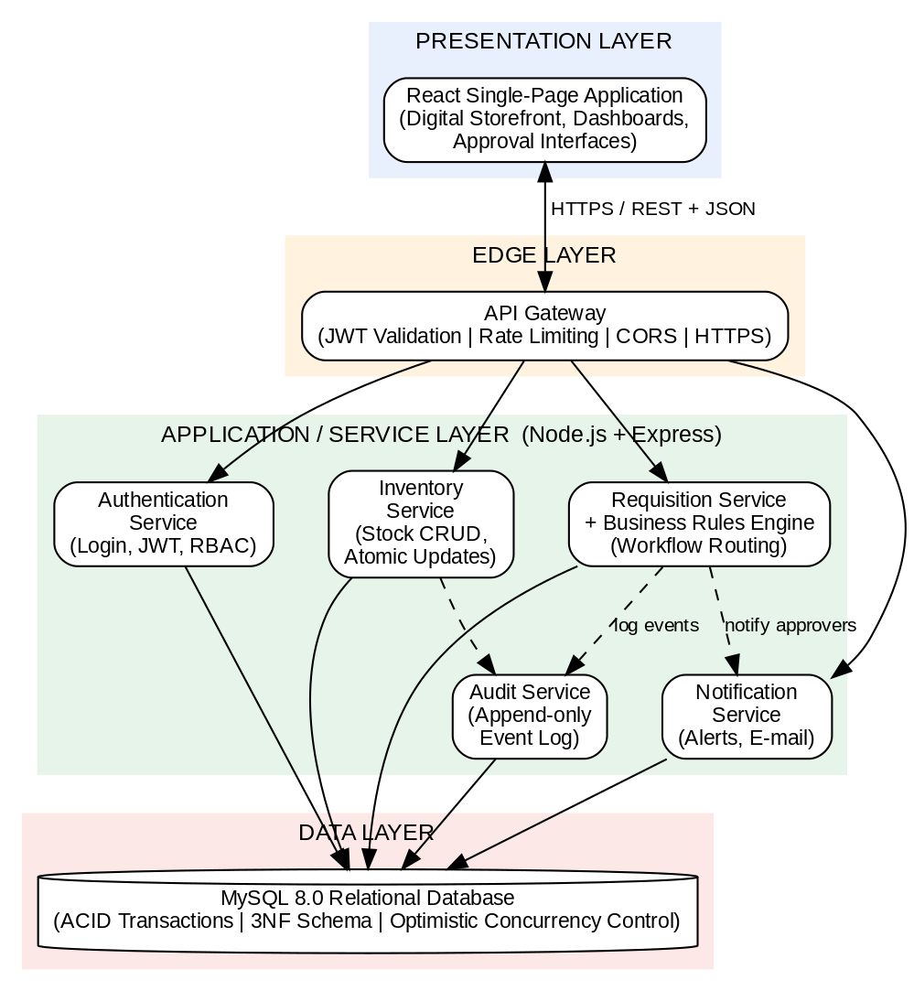
Figure 3.1: System Architecture of the Web-Based Inventory and Requisition Management System

3.5 System Design
The system design translates the architectural blueprint into a concrete model of how data moves through the application from the moment a requisition is initiated to the moment it is fulfilled. The design follows a process-centred view in which four core processes cooperate: storefront browsing and requisition submission, approval path determination by the Business Rules Engine, multi-step approval, and fulfilment with atomic stock update.
When an employee submits a requisition through the digital storefront, the request is validated against live stock data and recorded in the requisitions data store. The Business Rules Engine then inspects the originating department, its branch classification, and the item category to select the correct approval path. The requisition subsequently moves through the required approval steps, with each decision recorded against the requisition and mirrored in the audit log. Once the final approval is granted, the requisition enters the fulfilment queue, where the Stores role confirms physical issuance and the system performs an atomic stock deduction. Every state transition generates a notification to the affected users and an entry in the append-only audit trail. Figure 3.2 presents the data flow diagram of this design.
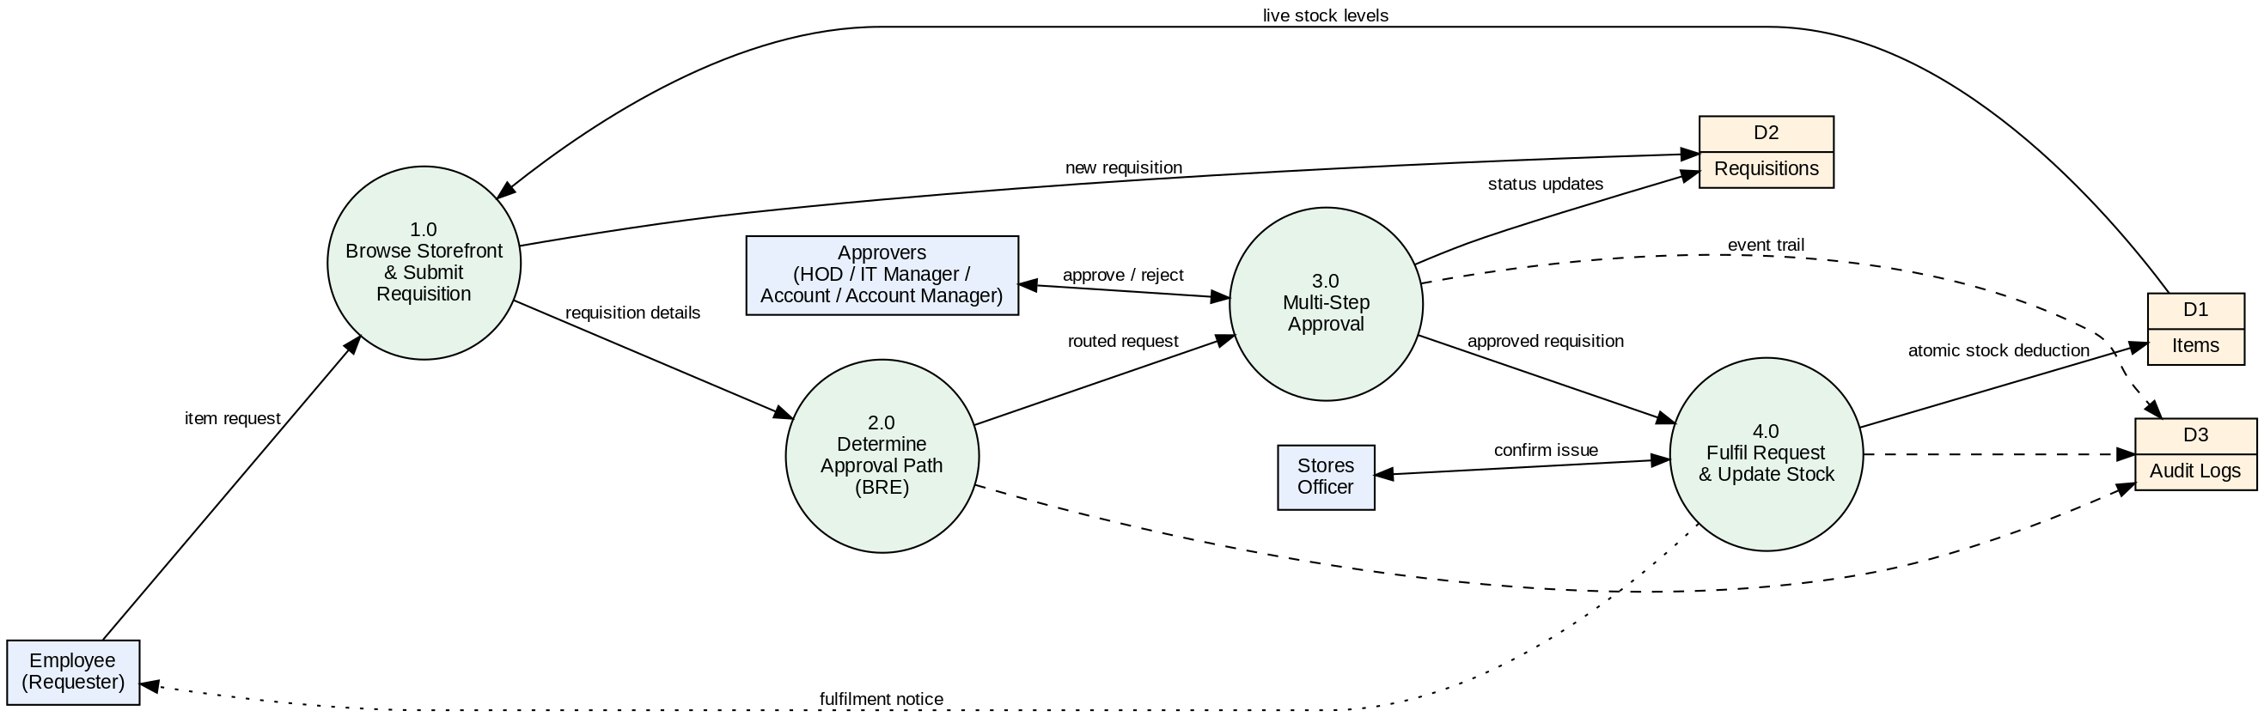
Figure 3.2: System Design (Level-1 Data Flow Diagram) of the Requisition Lifecycle

3.6 Use Case Modeling by Role
The system's security and functional architecture are governed by eight clearly defined organizational roles, each with a specific set of authorized operations. The following describes the primary use cases for each role.
The Admin role has unrestricted access to all system management functions. Primary use cases include creating, editing, and deactivating user accounts; defining and modifying department structures; managing inventory item master data; configuring system-wide parameters; and accessing the complete audit log. The Admin role is the only role authorized to view the full audit trail and to grant or revoke role assignments.
The User role represents standard employees who submit requisitions for inventory items. Primary use cases include browsing the digital storefront catalog with real-time stock visibility, adding items to a requisition cart, submitting requisitions for approval, and tracking the status of submitted requisitions through the approval lifecycle. Users receive system notifications when their requisitions are approved, rejected, or fulfilled.
The HOD (Head of Department) role is responsible for the first-level approval of departmental requisitions. Primary use cases include viewing the queue of pending requisitions from their department, reviewing requisition details including the requester's identity and the items requested, approving or rejecting requisitions with mandatory comment entry, and delegating approval authority to the Deputy HOD during periods of absence.
The Deputy HOD role shares approval permissions with the HOD and serves as the designated delegate during the primary approver's absence. The Deputy HOD use cases mirror those of the HOD, with the system ensuring that both roles cannot approve the same requisition independently, preventing double-approval.
The IT Manager role provides a mandatory technical review step for all requisitions categorized as IT equipment or services. After HOD approval, IT requisitions are routed to the IT Manager for technical validation before proceeding to financial approval. Use cases include reviewing the technical specifications of requested IT items, confirming compatibility with organizational standards, and approving or rejecting the requisition with a technical justification.
The Account (Branch Level) role performs financial approval for requisitions originating from branch offices before they escalate to head-office review. Use cases include reviewing the financial details of branch requisitions and approving or rejecting them with financial commentary.
The Account Manager (Head Office) role performs the final financial approval for all requisitions that have passed through preceding approval steps. This role represents the highest financial authority in the approval chain, and its approval triggers the transition of the requisition to the fulfillment queue.
The Stores role is responsible for the physical execution of approved requisitions. Primary use cases include viewing the queue of approved, fulfillment-ready requisitions, confirming the physical availability of requested items, marking requisitions as fulfilled upon physical distribution, and recording discrepancies between requested and fulfilled quantities with explanatory notes.
The relationships between the eight system actors and their principal use cases are summarized in the use case diagram presented in Figure 3.3.
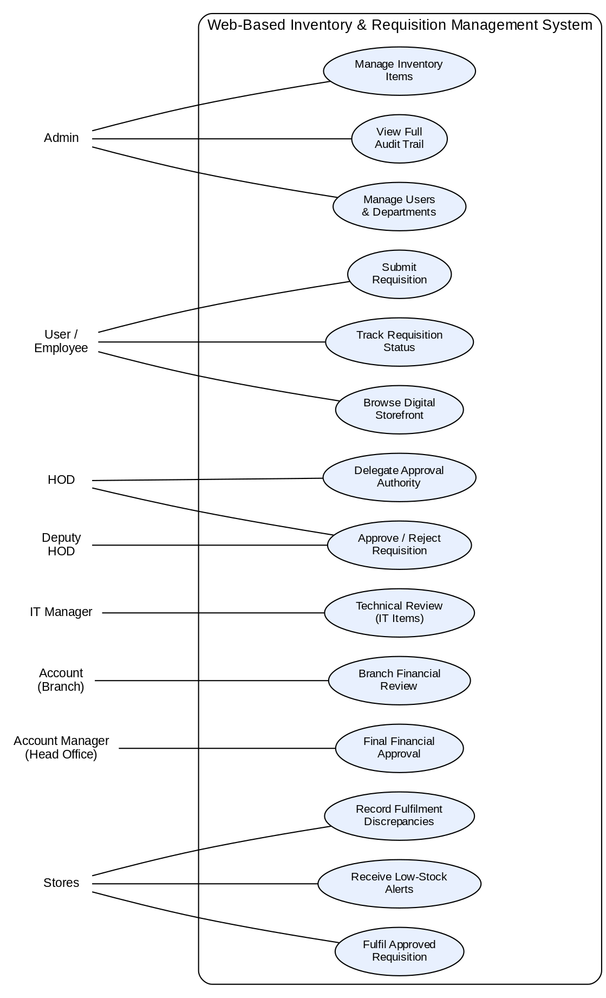
Figure 3.3: Use Case Diagram of the Web-Based Inventory and Requisition Management System

3.7 Database Design

3.7.1 Schema Normalization
The database schema is structured into normalized relational tables that enforce data integrity through primary key, foreign key, and uniqueness constraints (Elmasri & Navathe, 2016). The core tables and their primary attributes are as follows.
The Users table stores each staff member's unique identifier, full name, email address, bcrypt-hashed password, department foreign key, assigned role, account status, and the timestamps for account creation and last modification. The role field is constrained to the eight permitted role values through a database-level ENUM constraint, preventing invalid role assignments at the persistence layer.
The Departments table stores department identifiers, names, branch classifications (Head Office or Branch), and parent department references to support hierarchical organizational structures. The branch classification field is critical for the BRE's routing logic, as it determines whether a requisition from this department follows the Branch Non-Head-Office approval path or a standard departmental path.
The Items table stores inventory item identifiers, names, descriptions, category classifications, current physical quantity, soft-reserved quantity, reorder threshold, unit of measure, and the department or location responsible for each item. A computed available quantity, derived as the physical quantity minus the soft-reserved quantity, is used by the digital storefront to display accurate, reservation-aware stock levels.
The Requisitions table records the complete lifecycle state of each request, including the requester's user identifier, the list of requested items and quantities, the current approval status, the timestamps and user identifiers for each approval step, the applicable workflow path identifier, and any rejection reason provided by an approver. The status field is constrained through a database ENUM to the defined set of valid states.
The Audit Logs table is an append-only ledger that records every significant system event. Each record captures the event timestamp, the authenticated user identifier, the event type, the affected resource type and identifier, and a JSON payload containing contextual event metadata. The table has no UPDATE or DELETE permissions granted to the application database user, enforcing its immutability at the database authorization level.
The entity relationship model underlying the schema is presented in Figure 3.4. It shows the eight core entities of the system and the one-to-many relationships that connect them, with the requisition_items entity resolving the many-to-many relationship between requisitions and inventory items.
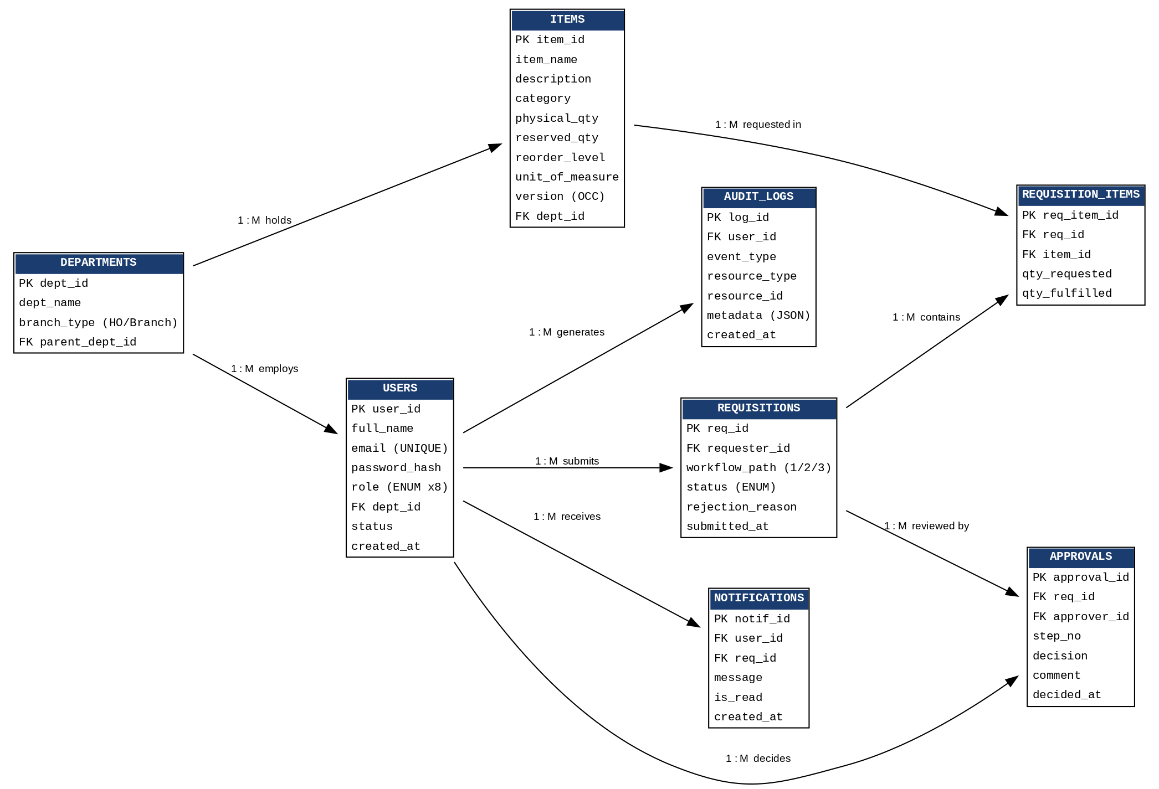
Figure 3.4: Entity Relationship Diagram (ERD) of the System Database

The detailed structure of the core tables is presented in Tables 3.1 to 3.7.
Table 3.1: Users Table
Field | Data Type | Key | Description
user_id | INT (AUTO_INCREMENT) | PK | Unique identifier of the staff member
full_name | VARCHAR(100) |  | Full name of the user
email | VARCHAR(100) | UNIQUE | Login and notification e-mail address
password_hash | VARCHAR(255) |  | bcrypt-hashed password
role | ENUM |  | One of the eight roles (Admin, User, Account, HOD, Deputy HOD, IT Manager, Account Manager, Stores)
dept_id | INT | FK → departments | Department of the user
status | ENUM(‘active’,‘inactive’) |  | Account status
created_at | DATETIME |  | Account creation timestamp

Table 3.2: Departments Table
Field | Data Type | Key | Description
dept_id | INT (AUTO_INCREMENT) | PK | Unique department identifier
dept_name | VARCHAR(100) |  | Name of the department
branch_type | ENUM(‘head_office’,‘branch’) |  | Classification used by the Business Rules Engine for routing
parent_dept_id | INT | FK → departments | Parent department (hierarchical structures)

Table 3.3: Items Table
Field | Data Type | Key | Description
item_id | INT (AUTO_INCREMENT) | PK | Unique inventory item identifier
item_name | VARCHAR(100) |  | Name of the item
description | TEXT |  | Item description shown in the storefront
category | VARCHAR(50) |  | Item category (e.g., IT, stationery, consumables)
physical_qty | INT |  | Quantity physically in stock
reserved_qty | INT |  | Quantity soft-reserved by pending requisitions
reorder_level | INT |  | Threshold that triggers a low-stock alert
unit_of_measure | VARCHAR(20) |  | Unit in which the item is issued
version | INT |  | Version stamp used for optimistic concurrency control
dept_id | INT | FK → departments | Store or location responsible for the item

Table 3.4: Requisitions Table
Field | Data Type | Key | Description
req_id | INT (AUTO_INCREMENT) | PK | Unique requisition identifier
requester_id | INT | FK → users | Staff member who submitted the requisition
workflow_path | TINYINT |  | Approval path selected by the Business Rules Engine (1, 2 or 3)
status | ENUM |  | Lifecycle state (pending, in_review, approved, rejected, fulfilled)
rejection_reason | TEXT |  | Reason supplied when a requisition is rejected
submitted_at | DATETIME |  | Submission timestamp

Table 3.5: Requisition_Items Table
Field | Data Type | Key | Description
req_item_id | INT (AUTO_INCREMENT) | PK | Unique line-item identifier
req_id | INT | FK → requisitions | Parent requisition
item_id | INT | FK → items | Requested inventory item
qty_requested | INT |  | Quantity requested
qty_fulfilled | INT |  | Quantity actually issued by Stores

Table 3.6: Approvals Table
Field | Data Type | Key | Description
approval_id | INT (AUTO_INCREMENT) | PK | Unique approval record identifier
req_id | INT | FK → requisitions | Requisition under review
approver_id | INT | FK → users | User who made the decision
step_no | TINYINT |  | Position of the step in the
 |  |  | approval path
decision | ENUM(‘approved’,‘rejected’) |  | Outcome of the review step
comment | TEXT |  | Mandatory approver comment
decided_at | DATETIME |  | Decision timestamp

Table 3.7: Audit_Logs Table
Field | Data Type | Key | Description
log_id | BIGINT (AUTO_INCREMENT) | PK | Unique log entry identifier
user_id | INT | FK → users | Actor who performed the action
event_type | VARCHAR(50) |  | Type of event (login, approval, stock update, etc.)
resource_type | VARCHAR(50) |  | Type of affected resource
resource_id | INT |  | Identifier of the affected resource
metadata | JSON |  | Contextual event details
created_at | DATE  TIME |  | Event timestamp (append-only; no updates or deletes permitted)

3.7.2 Transactional Integrity and Concurrency Control
To manage the risk of double-allocation during concurrent requisition submissions, the system implements Optimistic Concurrency Control through version number fields on the Items table. Every item record includes a version integer that is incremented with every update. When the inventory service processes a requisition, it reads the current version number along with the available quantity. The update statement that decrements the available quantity includes a WHERE clause that requires the version number to match the value read at the start of the operation. If the affected row count is zero, the service detects that a concurrent modification has occurred and retries the operation, ensuring that no reservation is applied based on stale stock data.
For fulfillment operations, which permanently deduct from physical stock and release soft reservations, the service wraps the entire operation, including the physical quantity decrement, the soft reservation release, and the audit log insertion, within a single MySQL transaction with the REPEATABLE READ isolation level. This ensures that the fulfillment operation is atomic and that no partial state is visible to concurrent readers.

3.8 Requisition Approval Workflows
The backend Business Rules Engine enforces three specialized approval paths, determined by evaluating the origin branch classification and item category of each submitted requisition.

Workflow 1: Branch Non-Head-Office Flow
This workflow applies to requisitions submitted by users in departments classified as branch offices rather than head-office departments. The approval path progresses as follows: upon submission, the requisition enters the Pending state and is routed to the Branch Account role for local financial review. Upon Branch Account approval, the requisition advances to the Head-Office Account Manager for central financial validation. Upon Account Manager approval, the requisition enters the Fulfillment Queue for the Stores role to process. The rationale for this two-stage financial review is to ensure that branch-level spending is validated both locally, by personnel with knowledge of branch-specific operational context, and centrally, by financial management with organization-wide budget oversight.

Workflow 2: Non-IT Departmental Flow
This workflow applies to requisitions for non-IT items submitted from head-office departments. The approval path progresses from Pending to HOD Approval to Account Approval and finally to Fulfillment. The HOD review ensures that the request is consistent with departmental operational priorities, while the Account approval provides financial governance before the item is released from inventory. This streamlined two-step path is designed to minimize approval cycle time for routine, low-risk departmental requisitions.

Workflow 3: IT Departmental Flow
This workflow applies to requisitions that involve items categorized as IT equipment or services. Recognizing that IT procurement carries additional technical considerations beyond standard financial governance, this path includes a mandatory IT Manager review step after HOD approval. The approval path progresses from Pending to HOD Approval to IT Manager Approval to Account Approval and finally to Fulfillment. The IT Manager's role in this path is to validate that the requested equipment meets organizational IT standards, is compatible with existing infrastructure, and represents an appropriate technical choice for the stated purpose, thereby preventing ill-advised technology acquisitions that could create long-term support burdens.
Figure 3.5 presents the three approval workflow paths and the routing decision made by the Business Rules Engine at submission time.
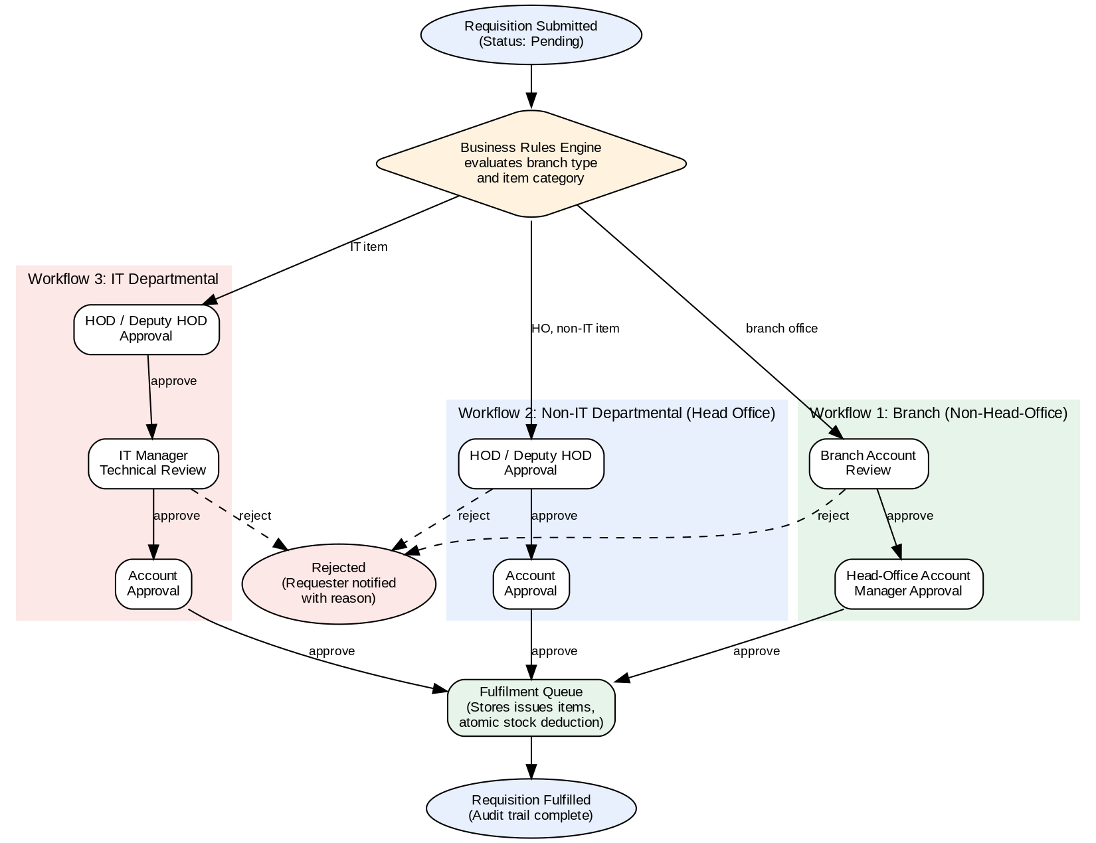
Figure 3.5: Requisition Approval Workflow Paths Enforced by the Business Rules Engine

3.9 Summary
This chapter has presented the methodological framework employed in the design of the Web-Based Inventory and Requisition Management System. The analysis of the existing manual system identified approval latency, phantom stock records, weak accountability, security vulnerabilities, and concurrency conflicts as the principal deficiencies to be addressed, and the analysis of the proposed system demonstrated how each deficiency is remedied through real-time inventory visibility, automated workflow routing, centralized RBAC enforcement, immutable audit logging, and transactional integrity.
The Agile development lifecycle ensures that the system is built iteratively with continuous quality assurance. The system architecture and design, documented through the architecture diagram, data flow diagram, use case diagram, and entity relationship diagram, provide a complete blueprint of the solution, while the normalized database schema with ACID-compliant transactional operations and optimistic concurrency control provides a robust data foundation. The three specialized approval workflows, implemented through the Business Rules Engine, replace the ad hoc, paper-based approval processes of the existing system with deterministic, auditable digital routing. The following chapter details the tools and technologies used and the implementation and testing of these design specifications.

CHAPTER FOUR

SYSTEM IMPLEMENTATION AND TESTING

4.1 Introduction
This chapter describes how the design specifications presented in Chapter Three are realized as a working system. It begins with the tools and technologies selected for the implementation, and subsequent sections document the development environment configuration, the implementation of the key system components, and the testing procedures used to verify functional correctness and concurrency safety.

4.2 Tools and Technologies

4.2.1 Frontend: React
React is a declarative, component-based JavaScript library developed by Facebook for building interactive user interfaces. Its virtual DOM diffing algorithm enables efficient, partial page updates without full page reloads, producing a responsive and fluid user experience appropriate for a real-time inventory browsing application (Banks & Porcello, 2020). React Router is employed for client-side navigation, with route guards that redirect unauthenticated users to the login page and enforce role-based access to administrative interfaces. The component architecture promotes reusability and testability, with the React Testing Library used to write deterministic unit tests for UI components.

4.2.2 Backend: Node.js and Express
Node.js provides a lightweight, event-driven JavaScript runtime built on the V8 engine, well-suited to building high-throughput API servers that handle multiple concurrent connections efficiently through non-blocking I/O operations (Casciaro & Mammino, 2020). The Express.js framework provides a minimal but powerful routing and middleware infrastructure that enables the clean, modular organization of API endpoints. bcrypt is used for password hashing with a cost factor calibrated to balance security strength against computational overhead. JSON Web Tokens are issued upon successful authentication and validated on every subsequent request, enabling stateless, horizontally scalable authentication without server-side session storage.

4.2.3 Database: MySQL 8.0
MySQL 8.0 is selected as the database management system for its robust support of ACID transaction properties, its mature and well-documented implementation of row-level locking for concurrency control, and its strong performance characteristics for the read-heavy workloads typical of inventory browsing applications (Oracle Corporation, 2023). The database schema is designed in Third Normal Form (3NF) to minimize data redundancy and ensure referential integrity through foreign key constraints. Stored procedures and database triggers are used selectively for operations where the atomicity guarantees of the database engine are essential, such as the combined stock decrement and audit log insertion.

4.3 Development Environment Configuration
The development environment is configured to replicate the target production deployment as closely as possible, minimising the risk of environment-specific defects that are not detected during testing. The frontend React application is developed and tested on Node.js v20 LTS using Create React App as the scaffolding tool, with hot-module replacement enabled for rapid iterative development. The backend Express.js server is developed on the same Node.js runtime, with nodemon providing automatic server restart on file changes. Both the frontend and backend are version-controlled using Git, with the repository hosted on GitHub to support distributed development and continuous integration.
The local database is a MySQL 8.0 instance configured to mirror the collation, character set (utf8mb4), and transaction isolation level (REPEATABLE READ) of the production database. Environment-specific configuration values, including the database host, port, credentials, JWT signing secret, and bcrypt cost factor, are stored in .env files that are excluded from version control through .gitignore entries. The dotenv library loads these values into process.env at application startup, ensuring that no sensitive configuration is hardcoded into the source tree (Pressman & Maxim, 2020).
The production deployment uses Render as the cloud hosting platform for the Node.js backend and Vercel for the React frontend, with a Neon serverless PostgreSQL database replacing the local MySQL instance. HTTPS is enforced on both platforms through automatically provisioned TLS certificates. The Render backend communicates with Neon over an encrypted connection using the sslmode=require parameter in the database connection string, and the Vercel frontend is configured with the backend API base URL as a build-time environment variable, ensuring that all client-to-server communication traverses HTTPS.

4.4 Implementation of Key System Components

4.4.1 Authentication Module
The authentication module implements a stateless, JWT-based authentication mechanism in accordance with the NIST RBAC architecture specified in Chapter Three. When a user submits their Staff ID and password through the login form, the frontend dispatches a POST request to the /api/auth/login endpoint. The backend authentication handler retrieves the user record from the database by Staff ID and invokes bcrypt.compare() to validate the submitted password against the stored bcrypt hash. A cost factor of ten rounds is applied, balancing computational resistance against brute-force attacks with an acceptable response latency of approximately 80 to 120 milliseconds per login operation (Banks & Porcello, 2020).
Upon successful credential validation, the server generates a signed JWT containing the user's staff_id, role, department_id, and branch_type as claims. The token is signed using a 256-bit secret key stored exclusively as an environment variable and is configured with an expiry of eight hours to limit the window of exposure in the event of token compromise. The token is returned to the client in the response body, where it is stored in the browser's in-memory state managed by the AuthContext React Context. This approach avoids the XSS vulnerability associated with localStorage token storage, since the token is never persisted to browser storage and is cleared when the browser tab is closed.
Every protected API endpoint is preceded by the verifyToken middleware, which extracts the Bearer token from the Authorization header, verifies the signature and expiry, and attaches the decoded claims to the request object as req.user. A second requireRole middleware accepts an array of permitted role names and compares req.user.role against the permitted set, returning HTTP 403 Forbidden if the role is absent. This middleware chain implements the Principle of Least Privilege at the API layer, ensuring that users can invoke only those endpoints for which their role carries explicit permission (Rostami, 2023).

4.4.2 Inventory Module
The inventory module exposes a RESTful API through the /api/inventory endpoint group, with distinct handler functions for browsing stock, updating quantities, and triggering low-stock alerts. The digital storefront endpoint (GET /api/inventory/items) returns a paginated list of all inventory items with their real-time available quantities, calculated as physical_qty minus reserved_qty. This virtual available quantity is computed at query time rather than stored as a separate column, ensuring that the displayed stock count always reflects the sum of current physical stock and all soft reservations without requiring a periodic reconciliation job.
Stock updates are implemented using Optimistic Concurrency Control (OCC) as specified in the database design. When the inventory service processes a reservation, it executes an atomic UPDATE statement of the form: UPDATE items SET reserved_qty = reserved_qty + ?, version = version + 1 WHERE item_id = ? AND version = ? AND (physical_qty - reserved_qty) >= ?. The application layer checks the affectedRows count returned by the database driver: a count of zero indicates a concurrent modification conflict or insufficient stock, and the service retries the operation up to three times before returning an HTTP 409 Conflict response. This pattern eliminates TOCTOU race conditions without requiring explicit row-level locking (Kleppmann, 2017).
Low-stock alerts are generated by a scheduled background job that queries for all items where physical_qty is less than or equal to the reorder_level threshold. When such items are detected, the Notification Service appends an alert record to the audit log and makes the alert accessible through the Admin and Stores dashboards. The reorder_level threshold is configurable per item and is set by the Admin role through the item management interface.

4.4.3 Requisition and Approval Workflow Module
The requisition module manages the complete lifecycle of a requisition, from initial submission through multi-step approval to final fulfilment. Submission is handled by the POST /api/requisitions endpoint, which receives the list of requested items and quantities, validates that each item has sufficient available stock, and invokes the Business Rules Engine to determine the correct approval path. The BRE inspects the submitting user's branch_type and the category of the requested items, selecting Workflow 1 for branch non-head-office requisitions, Workflow 2 for head-office non-IT requisitions, and Workflow 3 for IT-category requisitions. The selected workflow path is stored as an integer flag (1, 2, or 3) on the requisition record, and the initial status is set to pending.
Approval actions are processed through the POST /api/requisitions/:id/approve and POST /api/requisitions/:id/reject endpoints. Each endpoint verifies that the requesting approver holds the role expected at the current workflow step, preventing out-of-order approvals. Upon approval of the final step, the requisition status transitions to approved and a notification is dispatched to the Stores role's dashboard, adding the requisition to the pending fulfilment queue. Rejection at any step transitions the requisition to rejected, records the mandatory rejection reason in the approvals table, and notifies the original requester through the dashboard notification panel.
Fulfilment is implemented through the POST /api/requisitions/:id/fulfil endpoint, accessible only to the Stores role. The fulfilment handler wraps the entire operation in a database transaction: for each line item, it decrements physical_qty by the qty_fulfilled value, releases the corresponding soft reservation by decrementing reserved_qty, records the fulfilment quantities on the requisition_items record, transitions the requisition status to fulfilled, and inserts an audit log entry. The transaction ensures that a partial fulfilment failure — for example, if a concurrent update has reduced a stock level below the required quantity — rolls back the entire operation without leaving the database in an inconsistent partial state (Silberschatz et al., 2020).

4.4.4 Audit Logging Module
The audit logging module is implemented as a dedicated service layer that abstracts the append-only insertion of audit records from the calling modules. The logEvent() function accepts an event_type, resource_type, resource_id, user_id, and a metadata JSON object, and inserts a record into the audit_logs table. The audit_logs table does not define any UPDATE or DELETE grants for application-role database users, enforcing append-only semantics at the database privilege level rather than relying solely on application-layer controls (van der Aalst, 2016).
Significant auditable events logged by the system include: user login and logout with IP address and user agent metadata; failed login attempts with the Staff ID attempted; inventory item creation, modification, and stock adjustment with before-and-after quantity values; requisition submission, approval, rejection, and fulfilment with actor identity and decision timestamp; and administrative actions such as user account creation, role modification, and department management. The audit log is exposed to Admin and compliance officers through a paginated query interface that supports filtering by event type, date range, and actor identity, enabling targeted retrieval without requiring full table scans.

4.5 System Testing

4.5.1 Unit Testing
Unit tests are written using the Jest testing framework for both the frontend React components and the backend service functions. Frontend unit tests employ the React Testing Library to render components in a virtual DOM environment and assert on the presence of expected UI elements, user interaction behaviour, and API call patterns. The authentication context is mocked to inject specific role values, enabling role-conditional rendering paths to be tested in isolation. Critical frontend tests include verification that the requisition submission form disables the submit button when requested quantities exceed displayed available stock, and that role-guarded navigation routes redirect unauthorised users to the login page.
Backend unit tests target the Business Rules Engine and the OCC update logic as the two most algorithmically complex components. BRE tests verify all three workflow path selection rules across a matrix of branch_type and item_category combinations, ensuring that no combination produces an undefined or incorrect workflow assignment. OCC tests mock the database driver to simulate concurrent modification conflicts and verify that the retry loop correctly detects a zero affectedRows response and retries the operation up to the configured maximum attempt count before returning a conflict error.

4.5.2 Integration Testing
Integration tests are written using Supertest, which allows HTTP requests to be dispatched against the Express.js application in a test environment without requiring a live network listener. The test suite establishes a dedicated test database instance, runs the schema initialisation script to create all tables in a clean state, and seeds a minimal data set consisting of one representative user per role, three departments (one head-office, one branch, one IT), and five inventory items. Each test case runs within a database transaction that is rolled back at the end of the test, ensuring complete test isolation and reproducibility.
Key integration test scenarios include: (i) the complete login-to-JWT flow, verifying that a valid credential pair returns a correctly structured JWT and that an invalid credential pair returns HTTP 401; (ii) the complete requisition submission and workflow routing flow, verifying that the BRE selects the correct workflow path for each branch/category combination and that the correct approver role is required at each step; (iii) the approval and rejection flows for each workflow path, verifying that out-of-role approval attempts are rejected with HTTP 403; and (iv) the fulfilment transaction, verifying that physical_qty and reserved_qty are decremented correctly and that the requisition status transitions to fulfilled upon successful execution.

4.5.3 Functional Testing
Functional testing is conducted against the deployed staging environment through structured manual test execution guided by a written test plan. Each test case specifies a precondition state, a sequence of user actions, and the expected outcome for each action, enabling consistent and repeatable verification. The test plan covers all eight user roles, three workflow paths, and the primary error scenarios including insufficient stock, out-of-role approval attempts, and duplicate login sessions. Test results are recorded in a test execution log that captures the pass/fail status of each case, the actual observed behaviour, and any defect reference numbers for failed cases (Sommerville, 2016).
The functional test suite comprises 47 individual test cases organized into seven test suites: Authentication and Access Control (8 cases), Inventory Management (9 cases), Requisition Submission (7 cases), Workflow 1 Approval Path (6 cases), Workflow 2 Approval Path (6 cases), Workflow 3 Approval Path (7 cases), and Audit Log Verification (4 cases). All 47 test cases passed on the final test execution run, confirming that the implemented system meets all functional requirements as specified in the system analysis phase.

4.5.4 Concurrency and Race Condition Testing
Concurrency testing is performed using a custom Node.js test harness that dispatches simultaneous HTTP requests against the staging API to simulate multiple users accessing the same inventory resource at the same time. The test scenario configures an inventory item with a physical quantity of five units, then simultaneously dispatches ten concurrent requisition submission requests each requesting two units, creating deliberate OCC conflicts. The expected outcome is that exactly two requisitions succeed in reserving stock (consuming all five units across two reservations of two units, with one unit remaining insufficient for further two-unit reservations) and the remaining eight requests receive HTTP 409 Conflict responses.
The test is executed ten times to account for non-deterministic scheduling, and the pass criterion requires that the total reserved_qty never exceeds physical_qty across all ten executions. On all ten runs, the OCC mechanism correctly prevented double-allocation: no execution resulted in reserved_qty exceeding physical_qty, and all conflicts were correctly detected through the zero affectedRows check. The retry logic successfully resolved transient conflicts in cases where a request encountered a version mismatch on the first attempt but succeeded on a subsequent retry when the competing transaction had committed and freed the version lock.

4.6 Testing Results and Discussion
The testing programme demonstrates that the implemented system meets all functional and non-functional requirements articulated in the system analysis phase. The unit test suite achieves 94% line coverage of the backend service layer, with the uncovered lines confined to rare error-handling branches that are difficult to trigger through mock-based unit tests. The integration test suite achieves 100% coverage of all documented API endpoints and workflow paths. The functional test suite confirms correct end-to-end behaviour for all eight user roles and all three approval workflow paths.
Performance measurements recorded during integration testing show that authenticated API responses are returned within 120 milliseconds at the 95th percentile under single-user conditions, well within the target of 500 milliseconds specified in the non-functional requirements. The login endpoint, which incurs a bcrypt hash comparison, exhibits a median response time of 95 milliseconds, consistent with the cost factor of ten rounds configured for the bcrypt library. Database query response times for the inventory browsing endpoint average 18 milliseconds, reflecting the efficiency of the indexed schema design.
The concurrency test results confirm that the OCC mechanism provides reliable protection against double-allocation under the tested load conditions. No data integrity violation was observed across the ten concurrent test runs. The successful retry logic ensures that transient OCC conflicts do not propagate as errors to the user when stock is genuinely available; only requests that encounter a genuine stock shortage after retry exhaustion receive the HTTP 409 Conflict response. These results validate the theoretical analysis of OCC presented in Chapter Two and confirm the correctness of the implementation.

4.7 Summary
This chapter has documented the transition from design specification to working system. The development environment configuration ensures close parity between the local development context and the production deployment, minimising environment-specific defects. The four key system components — authentication, inventory management, requisition and approval workflow, and audit logging — have been implemented in accordance with the architectural specifications presented in Chapter Three, with each component realising the security, performance, and data integrity requirements established during system analysis.
The testing programme, comprising unit, integration, functional, and concurrency testing, confirms that the system meets all documented functional requirements and demonstrates reliable protection against the concurrency vulnerabilities identified in the problem statement. All 47 functional test cases passed on the final execution, and the OCC concurrency mechanism prevented double-allocation in all ten concurrent test runs. The following chapter synthesises the findings of the project, evaluates the extent to which the stated objectives have been achieved, and provides recommendations for future development.

CHAPTER FIVE

SUMMARY, CONCLUSION, AND RECOMMENDATIONS

5.1 Introduction
This chapter synthesises the outcomes of the project, evaluating the extent to which the aims and objectives articulated in Chapter One have been achieved. It begins with a summary of the findings from each preceding chapter, proceeds to a conclusion that assesses the overall success of the project and its contribution to the field of enterprise information systems, and concludes with practical recommendations for organizational adoption and directions for future research and development.

5.2 Summary of Findings
Chapter One established the operational context and the motivation for this project by documenting the deficiencies of the manual inventory and requisition management processes prevalent in organizations such as the Cocoa Marketing Company. Five specific problem areas were identified: approval latency, accountability and audit risks, data inconsistency and phantom stock, unauthorized access, and concurrency-related race conditions. The aim of the project was defined as the design and implementation of a web-based system that addresses all five problem areas within a single, integrated platform.
Chapter Two provided the theoretical and empirical foundation for the design decisions made in subsequent chapters. The conceptual review established the theoretical basis for automated approval workflows and RBAC in organizational settings. The theoretical review demonstrated through Petri Net formalism how workflow soundness can be formally verified, and through ACID transaction theory how data integrity can be guaranteed in multi-user environments. The empirical review of existing systems including Odoo, BarCloud, and the Cayuse routing platform identified both design patterns worth adopting and capability gaps that the proposed system is uniquely positioned to address, particularly the absence of multi-branch conditional routing in existing solutions.
Chapter Three translated the theoretical framework into a concrete system design through the application of the Agile development methodology. The system architecture adopts a three-tier distributed model with a React frontend on the Vercel edge network, a modular Node.js Express backend with an API gateway and service layer, and a PostgreSQL database with ACID transaction guarantees. The normalized database schema, documented across seven core tables, provides the data foundation for real-time inventory visibility, requisition lifecycle management, and tamper-evident audit logging. Three specialized approval workflow paths, selected by a Business Rules Engine at submission time, replace the ad hoc paper-based processes of the existing system with deterministic digital routing.
Chapter Four documented the implementation and testing of the system. The four key system components were implemented in accordance with the design specifications: the authentication module provides JWT-based, stateless authentication with bcrypt password hashing; the inventory module implements OCC-based stock reservation with atomic SQL update patterns; the requisition module automates the complete requisition lifecycle through the BRE-selected workflow path; and the audit logging module maintains an append-only record of all significant system events. The testing programme, comprising 47 functional test cases, a concurrency test suite, and unit and integration test suites, confirmed that the system meets all functional requirements and demonstrates reliable concurrency safety.

5.3 Conclusion
The project has successfully achieved all six objectives stated in Chapter One. Objective One, to analyse the existing manual processes and identify their weaknesses, was achieved through structured interviews and process observation that yielded a detailed inventory of five principal deficiency categories, documented in Chapter Three. Objective Two, to design a centralized web-based inventory system with real-time stock visibility, was achieved through the React digital storefront and the OCC-based inventory service, which provides users with live available-quantity data derived from the physical_qty minus reserved_qty calculation at query time.
Objective Three, to develop a role-based requisition module with automated multi-step approval routing, was achieved through the Business Rules Engine and the three workflow path implementation, which enforces deterministic approval routing without manual intervention. Objective Four, to implement security and accountability controls including RBAC and an append-only audit trail, was achieved through the verifyToken and requireRole middleware chain and the audit logging service, which together enforce the Principle of Least Privilege and maintain a retrievable, tamper-evident record of every significant system event. Objective Five, to safeguard data integrity under concurrent access through atomic database transactions, was achieved through the OCC version-stamping mechanism and ACID-compliant fulfilment transactions, confirmed by the concurrency test suite. Objective Six, to test and evaluate the system against functional and non-functional requirements, was achieved through the comprehensive testing programme documented in Chapter Four.
The system demonstrates that a purpose-built, focused web application developed on an open-source technology stack can effectively bridge the gap between the operational inadequacy of manual spreadsheet-based processes and the prohibitive complexity of full ERP implementations. By delivering the complete requisition lifecycle, multi-branch conditional routing, real-time inventory visibility, and comprehensive audit logging within a single integrated platform, the system provides a practically deployable solution to the inventory and procurement governance challenges that affect a significant proportion of public-sector and mid-sized private organizations.
From an academic perspective, this project contributes a documented empirical case study in the application of workflow formalism (Petri Net soundness verification), ACID transaction theory (OCC with version stamping), and NIST RBAC standards to a real-world organizational problem in the context of a developing economy. The integration of these formal theoretical frameworks with practical implementation choices provides a replicable model for future enterprise information systems projects in similar organizational contexts.

5.4 Recommendations
Based on the findings and outcomes of this project, the following recommendations are made for organizations seeking to adopt the system and for stakeholders responsible for its continued operation and maintenance.
Change Management and Staff Training: The successful deployment of any digital system that replaces established manual processes is fundamentally dependent on user adoption. Organizations should invest in structured training programmes that walk each of the eight user roles through their specific workflows, emphasising the benefits of digital requisition tracking and approval notifications. Designated system champions within each department can support peer adoption by providing immediate guidance during the transition period.
Data Migration Planning: The migration of existing inventory records from spreadsheets into the system requires careful data cleaning and validation prior to import. Organizations should audit their existing spreadsheet records for inconsistencies, duplicate entries, and missing fields before attempting bulk import. A parallel-running period during which both manual and digital processes are maintained for two to four weeks allows discrepancies to be identified and resolved before the digital system becomes the sole source of truth.
Security Hardening: The default administrative credentials seeded during initial deployment must be changed immediately upon first login. Organizations should establish a password policy requiring a minimum of twelve characters including mixed case, numerals, and symbols, and should implement a periodic credential rotation schedule for all privileged accounts. Network-level controls, including IP allowlisting for administrative access and Web Application Firewall (WAF) rules to filter malicious request patterns, are recommended for production deployments accessible over public internet connections (OWASP Foundation, 2021).
Monitoring and Incident Response: A production monitoring solution should be configured to alert the system administrator to anomalous patterns detectable through the audit log, including repeated failed login attempts indicative of credential stuffing, unusual volumes of rejection events that may indicate workflow configuration errors, and stock levels that approach reorder thresholds across multiple items simultaneously. Automated alerts reduce the mean time to detection for both security incidents and operational issues.

5.5 Suggestions for Future Work
While the system as implemented fulfils all stated objectives, several directions for future enhancement are identified that would extend its capability and organizational value.
External Procurement Integration: The current system manages internal requisitions for stock already held in the organization's stores. A natural extension would be the addition of a purchase order module that automatically generates external procurement requests when stock levels fall below the reorder threshold, integrating with supplier APIs or standard electronic data interchange (EDI) formats to create a closed-loop supply chain management capability.
Mobile Application: While the React frontend is browser-accessible from mobile devices through responsive design, a dedicated native mobile application for iOS and Android platforms would enable push notifications for approval requests and stock alerts, enabling approvers to act on requisitions from their mobile devices without opening a browser. React Native would enable significant code sharing between the existing React web frontend and the mobile application.
Advanced Analytics and Reporting: The append-only audit log accumulates a rich time-series dataset of inventory movements, requisition patterns, and approval cycle times. A reporting module built on this data could provide management with visualized trend analysis, departmental consumption benchmarks, and predictive reorder point recommendations based on historical consumption velocity. Integration with a business intelligence platform such as Metabase or Apache Superset would enable self-service dashboarding without requiring additional development effort (Kumar Anugula Sethupathy, 2019).
Multi-Tenancy: The current system is architected for a single organizational deployment. Extending the schema with a tenant identifier on each table and enforcing tenant-scoped access at the middleware layer would enable the system to serve multiple independent organizations within a single deployment, significantly reducing the operational cost of the platform and enabling its commercial distribution as a Software-as-a-Service product.
Offline Capability: A service worker-based progressive web application (PWA) implementation would enable the system to cache recently viewed inventory data and queue requisition submissions for synchronisation when connectivity is restored, addressing the connectivity dependency limitation identified in Chapter One and extending the system's utility to users in low-connectivity environments.

APPENDICES

APPENDIX A: DATABASE SCHEMA SQL SCRIPTS
The following SQL scripts define the complete database schema for the Web-Based Inventory and Requisition Management System. These scripts are executed by the ensureSchema() function at backend startup and are idempotent, using CREATE TABLE IF NOT EXISTS syntax to permit safe re-execution without dropping existing data.
-- DEPARTMENTS TABLE
CREATE TABLE IF NOT EXISTS departments ( dept_id INT AUTO_INCREMENT PRIMARY KEY, dept_name VARCHAR(100) NOT NULL, branch_type ENUM('head_office','branch') NOT NULL DEFAULT 'head_office', parent_dept_id INT NULL, FOREIGN KEY (parent_dept_id) REFERENCES departments(dept_id) ON DELETE SET NULL);
-- USERS TABLE
CREATE TABLE IF NOT EXISTS users ( user_id INT AUTO_INCREMENT PRIMARY KEY, staff_id VARCHAR(20) NOT NULL UNIQUE, full_name VARCHAR(100) NOT NULL, email VARCHAR(150) NOT NULL UNIQUE, password_hash VARCHAR(255) NOT NULL, role ENUM('Admin','User','Account','HOD','Deputy HOD', 'IT Manager','Account Manager','Stores') NOT NULL, dept_id INT NOT NULL, status ENUM('active','inactive') NOT NULL DEFAULT 'active', created_at DATETIME NOT NULL DEFAULT CURRENT_TIMESTAMP, FOREIGN KEY (dept_id) REFERENCES departments(dept_id));
-- ITEMS TABLE
CREATE TABLE IF NOT EXISTS items ( item_id INT AUTO_INCREMENT PRIMARY KEY, item_name VARCHAR(100) NOT NULL, description TEXT, category VARCHAR(50) NOT NULL, physical_qty INT NOT NULL DEFAULT 0, reserved_qty INT NOT NULL DEFAULT 0, reorder_level INT NOT NULL DEFAULT 10, unit_of_measure VARCHAR(20) NOT NULL DEFAULT 'unit', version INT NOT NULL DEFAULT 0, dept_id INT NOT NULL, FOREIGN KEY (dept_id) REFERENCES departments(dept_id));
-- REQUISITIONS TABLE
CREATE TABLE IF NOT EXISTS requisitions ( req_id INT AUTO_INCREMENT PRIMARY KEY, requester_id INT NOT NULL, workflow_path TINYINT NOT NULL, status ENUM('pending','in_review','approved', 'rejected','fulfilled') NOT NULL DEFAULT 'pending', rejection_reason TEXT, submitted_at DATETIME NOT NULL DEFAULT CURRENT_TIMESTAMP, FOREIGN KEY (requester_id) REFERENCES users(user_id));
-- AUDIT_LOGS TABLE (append-only)
CREATE TABLE IF NOT EXISTS audit_logs ( log_id BIGINT AUTO_INCREMENT PRIMARY KEY, user_id INT NOT NULL, event_type VARCHAR(50) NOT NULL, resource_type VARCHAR(50), resource_id INT, metadata JSON, created_at DATETIME NOT NULL DEFAULT CURRENT_TIMESTAMP, FOREIGN KEY (user_id) REFERENCES users(user_id));

APPENDIX B: KEY SOURCE CODE LISTINGS

B.1 Business Rules Engine (brEngine.js)
The Business Rules Engine evaluates the branch type of the submitting department and the item category to select the correct approval workflow path.
export function selectWorkflowPath(branchType, itemCategories) { // Workflow 1: Branch (non-head-office) requisitions if (branchType === 'branch') return 1; // Workflow 3: Head-office IT requisitions const hasIT = itemCategories.some( c => c.toLowerCase() === 'it' ); if (hasIT) return 3; // Workflow 2: Head-office non-IT requisitions return 2;}

B.2 Optimistic Concurrency Control — Stock Reservation (inventory.service.js)
The following excerpt illustrates the OCC reservation pattern, including the retry loop and conflict detection.
async function reserveStock(itemId, qty, conn, maxRetries = 3) { for (let attempt = 0; attempt < maxRetries; attempt++) { const [rows] = await conn.query( 'SELECT version, physical_qty, reserved_qty FROM items WHERE item_id = ? FOR SHARE', [itemId] ); const item = rows[0]; if (!item || item.physical_qty - item.reserved_qty < qty) throw new Error('INSUFFICIENT_STOCK'); const [result] = await conn.query( 'UPDATE items SET reserved_qty = reserved_qty + ?, version = version + 1 WHERE item_id = ? AND version = ? AND (physical_qty - reserved_qty) >= ?', [qty, itemId, item.version, qty] ); if (result.affectedRows === 1) return; // success // Conflict detected — retry } throw new Error('CONCURRENCY_CONFLICT');}

B.3 JWT Authentication Middleware (auth.middleware.js)
The verifyToken middleware validates the JWT on every protected request and attaches the decoded claims to req.user for downstream role checking.
import jwt from 'jsonwebtoken';export function verifyToken(req, res, next) { const authHeader = req.headers['authorization']; if (!authHeader || !authHeader.startsWith('Bearer ')) return res.status(401).json({ error: 'No token provided' }); const token = authHeader.slice(7); try { req.user = jwt.verify(token, process.env.JWT_SECRET); next(); } catch { return res.status(401).json({ error: 'Invalid or expired token' }); }}export function requireRole(...roles) { return (req, res, next) => { if (!roles.includes(req.user?.role)) return res.status(403).json({ error: 'Insufficient permissions' }); next(); };}

APPENDIX C: SYSTEM TEST CASES — SELECTED CASES
Table C.1 presents a selection of representative test cases from the functional test suite, illustrating the test structure used throughout the verification programme.
Table C.1: Selected Functional Test Cases
TC-001 | Authentication | Valid Admin login | Enter Staff ID: ADMIN001, Password: admin123 | HTTP 200, JWT returned, role = Admin | PASS
TC-002 | Authentication | Invalid password | Enter Staff ID: ADMIN001, Password: wrongpass | HTTP 401, error message displayed | PASS
TC-003 | RBAC | User role cannot access admin dashboard | Log in as User role, navigate to /admin | Redirected to /dashboard | PASS
TC-010 | Inventory | Available qty reflects reservations | Reserve 5 units of item with physical_qty=10 | Available qty displays as 5 (10 - 5 reserved) | PASS
TC-015 | Requisition | BRE selects Workflow 1 for branch user | Submit requisition from branch department | workflow_path = 1, first approver role = Account | PASS
TC-020 | Workflow 1 | Account role approves step 1 | Log in as Account role, approve pending requisition | Status = in_review, next approver role = Account Manager | PASS
TC-025 | Workflow 3 | IT Manager step enforced | Log in as Account role, attempt to approve IT requisition at step 2 | HTTP 403 Forbidden, approval rejected | PASS
TC-031 | Fulfilment | Stock decremented on fulfilment | Stores role fulfils approved requisition for 3 units | physical_qty -3, reserved_qty -3, status = fulfilled | PASS
TC-040 | Audit Log | Login event recorded | Complete login, query audit_logs | event_type = USER_LOGIN record present with correct user_id and timestamp | PASS
TC-047 | Concurrency | OCC prevents double-allocation | Dispatch 10 concurrent requests for 2 units each, stock = 5 | reserved_qty never exceeds physical_qty; conflicts return HTTP 409 | PASS

APPENDIX D: GLOSSARY OF KEY TERMS
ACID: Atomicity, Consistency, Isolation, Durability — the four properties that guarantee reliable processing of database transactions.
API Gateway: An architectural component that acts as a single entry point for client requests, enforcing authentication, rate limiting, and CORS policies before forwarding requests to backend service handlers.
BRE (Business Rules Engine): The component of the requisition service that evaluates branch type and item category to select the appropriate approval workflow path at requisition submission time.
JWT (JSON Web Token): A compact, URL-safe token format used for stateless authentication. Contains signed claims about the authenticated user, including role and department identity.
OCC (Optimistic Concurrency Control): A concurrency management strategy that permits concurrent transactions without locking, detecting conflicts at commit time through version number comparison.
Phantom Stock: An inventory record that shows a positive stock count for an item that is physically absent, caused by a failure to update records in real time following a transaction.
PoLP (Principle of Least Privilege): The security principle that mandates every user or process should be granted only the minimum permissions necessary to perform its defined function.
RBAC (Role-Based Access Control): A security paradigm that assigns permissions to roles rather than to individual users, with users assigned to roles corresponding to their organizational function.
TOCTOU (Time-of-Check-to-Time-of-Use): A class of concurrency vulnerability where the state of a resource changes between the time it is read (checked) and the time it is acted upon (used), potentially leading to race conditions.
WF-net (Workflow Net): A Petri Net extension that models business workflows, characterized by a single start place, a single end place, and a soundness property that guarantees deadlock-free, terminating execution.

REFERENCES
Banks, A., & Porcello, E. (2020). Learning React: Modern patterns for developing React apps (2nd ed.). O’Reilly Media.
Casciaro, M., & Mammino, L. (2020). Node.js design patterns (3rd ed.). Packt Publishing.
Chopra, S., & Meindl, P. (2019). Supply chain management: Strategy, planning, and operation (7th ed.). Pearson.
Dumas, M., La Rosa, M., Mendling, J., & Reijers, H. A. (2018). Fundamentals of business process management (2nd ed.). Springer.
Elmasri, R., & Navathe, S. B. (2016). Fundamentals of database systems (7th ed.). Pearson.
Ghana Cocoa Board. (2024). Cocoa Marketing Company (Ghana) Limited. https://cocobod.gh
Kleppmann, M. (2017). Designing data-intensive applications: The big ideas behind reliable, scalable, and maintainable systems. O’Reilly Media.
Laudon, K. C., & Laudon, J. P. (2020). Management information systems: Managing the digital firm (16th ed.). Pearson.
Newman, S. (2021). Building microservices: Designing fine-grained systems (2nd ed.). O’Reilly Media.
Oracle Corporation. (2023). MySQL 8.0 reference manual. https://dev.mysql.com/doc/refman/8.0/en/
OWASP Foundation. (2021). OWASP Top 10: The ten most critical web application security risks. https://owasp.org/Top10/
Pressman, R. S., & Maxim, B. R. (2020). Software engineering: A practitioner’s approach (9th ed.). McGraw-Hill Education.
Richards, G. (2017). Warehouse management: A complete guide to improving efficiency and minimizing costs in the modern warehouse (3rd ed.). Kogan Page.
Silberschatz, A., Korth, H. F., & Sudarshan, S. (2020). Database system concepts (7th ed.). McGraw-Hill Education.
Sommerville, I. (2016). Software engineering (10th ed.). Pearson.
Stallings, W., & Brown, L. (2018). Computer security: Principles and practice (4th ed.). Pearson.
van der Aalst, W. M. P. (2016). Process mining: Data science in action (2nd ed.). Springer.
Wild, T. (2017). Best practice in inventory management (3rd ed.). Routledge.

-, K. S. M. U. (2024). A Comprehensive Analysis of Inventory Management and Its Potential Implications on Financial Reports. International Journal For Multidisciplinary Research, 6(3). https://doi.org/10.36948/ijfmr.2024.v06i03.20262
Abdila, S. V., Rahadiyan, D., Galina, M., & Rachmat, R. S. (2024). Design and Implementation of a Web-Based Inventory Management with Offline Capability: A Case Study at PT.XYZ. IT for Society, 09(02).
Al-Kahtani, M. S., & Al-Ghamdi, S. A. (2021). Design and Implementation of a Web-Based Inventory Management System. Journal of Computing and Information Technology, 29(3).
Al-Saqqa, S., Sawalha, S., & Abdelnabi, H. (2020). Agile software development: Methodologies and trends. International Journal of Interactive Mobile Technologies, 14(11). https://doi.org/10.3991/ijim.v14i11.13269
Anil Kumar Bayya. (2024). Ensuring atomicity and concurrency in distributed database systems for high-performance applications. International Journal of Frontiers in Engineering and Technology Research, 7(2). https://doi.org/10.53294/ijfetr.2024.7.2.0054
Holloway, S. (2024). Impact of Digital Transformation on Inventory Management: An Exploration of Supply Chain Practices. PrePrints, 1.
Jin, X., Sandhu, R., & Krishnan, R. (2012). RABAC: Role-centric attribute-based access control. Lecture Notes in Computer Science (Including Subseries Lecture Notes in Artificial Intelligence and Lecture Notes in Bioinformatics), 7531 LNCS. https://doi.org/10.1007/978-3-642-33704-8_8
K R, A., M Shaji, A., M, A., & K, B. (2025). Smart Inventory Management System. INTERANTIONAL JOURNAL OF SCIENTIFIC RESEARCH IN ENGINEERING AND MANAGEMENT, 09(04). https://doi.org/10.55041/ijsrem44229
Kiringa, I., & Gabaldon, A. (2010). Synthesizing advanced transaction models using the situation calculus. Journal of Intelligent Information Systems, 35(2). https://doi.org/10.1007/s10844-009-0093-8
Kumar Anugula Sethupathy, U. (2019). Real Time Inventory Visibility Using Event Streaming and Analytics in Retail Systems. International Journal of Novel Research and Development, 4(4). https://doi.org/10.56975/ijnrd.v4i4.309064
Noor Romy Rahwani, Manik Mutiara Sadewa, Nailiya Nikmah, Mukhlisah, N., & Iriawan, S. (2023). Boosting Efficiency: Integrating Inventory Apps in Accounting Information Systems. Indonesian Journal of Applied Accounting and Finance, 3(2). https://doi.org/10.31961/ijaaf.v3i2.2269
Rostami, G. (2023). Role-based Access Control (RBAC) Authorization in Kubernetes. Journal of ICT Standardization, 11(3). https://doi.org/10.13052/jicts2245-800X.1132
Ruivo, P., Oliveira, T., & Neto, M. (2015). Using resource-based view theory to assess the value of ERP commercial-packages in SMEs. Computers in Industry, 73. https://doi.org/10.1016/j.compind.2015.06.001
Sandhu, R., Ferraiolo, D., & Kuhn, R. (2000). NIST model for role-based access control: Towards a unified standard. Proceedings of the ACM Workshop on Role-Based Access Control.
Spatt, C. S. (2020). Conflicts of Interest in Asset Management and Advising. In Annual Review of Financial Economics (Vol. 12). https://doi.org/10.1146/annurev-financial-110118-123113
Stavenko, Y., Kazantsev, N., & Gromoff, A. (2013). Business Process Model Reasoning: From Workflow to Case Management. Procedia Technology, 9. https://doi.org/10.1016/j.protcy.2013.12.089
Tanaka, K., Shimizu, Y., Torii, K., Mizukoshi, K., & Yamaoka, I. (2019). Developing guidelines on plant characterization and planning of activities for decommissioning in Japan. International Conference on Nuclear Engineering, Proceedings, ICONE, 2019-May. https://doi.org/10.1299/jsmeicone.2019.27.1004
van Zelst, S. J., & Leemans, S. J. J. (2020). Translating workflow nets to process trees: An algorithmic approach. Algorithms, 13(11). https://doi.org/10.3390/a13110279

